**CYBER SECURITY AND APPLICATION SECURITY LAB**

**ASSIGNMENT – 1**

***Date - August 11, 2023 Submitted to – Dr. Murugan K***  **Q1. Analysis of security in Unix/Linux.**

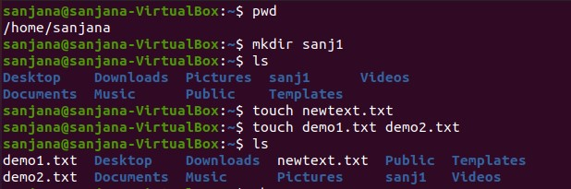

Here are some common security-related commands:

1. Check Logged-In Users:

* `who`: Shows currently logged-in users.



* `w`: Displays detailed information about currently logged-in users.

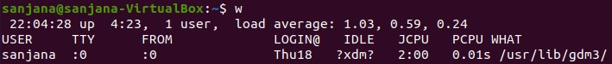

* `last`: Shows a list of recently logged-in users.

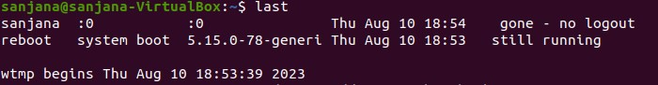

2. User Management:

* `useradd`: Add a new user
* `passwd`: Change user password.

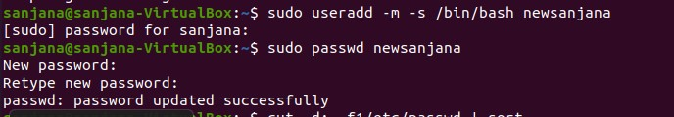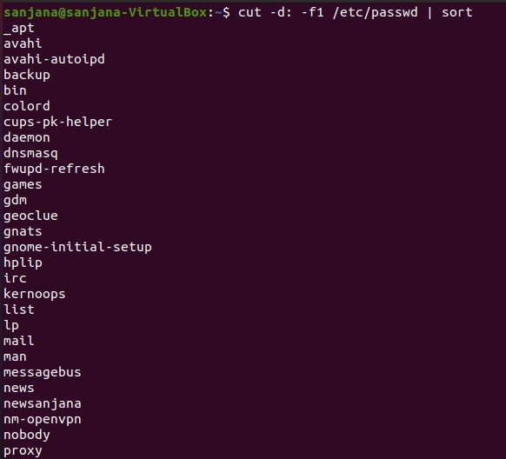

`userdel`: Delete a user

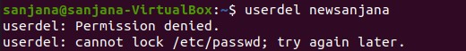

3. File and Directory Permissions:

- `ls -l`: List files and directories with detailed permissions.

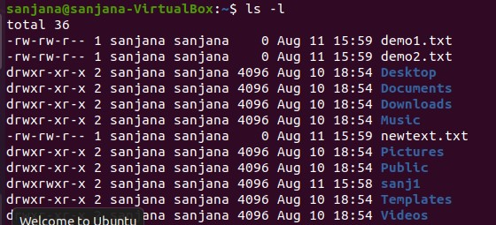

4. Firewall and Network Security:

* `iptables`: Configure firewall rules (legacy, use `nftables` for newer systems).

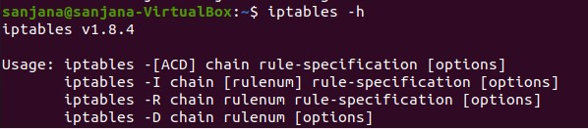

* `ufw`: Uncomplicated Firewall, a simpler interface for managing iptables.

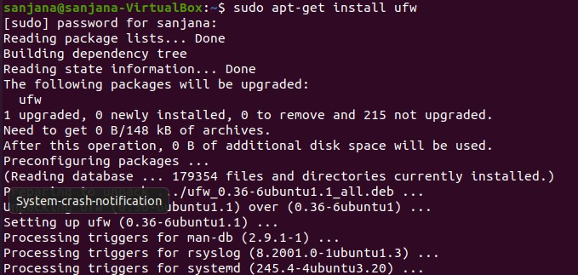

* `ss`: Display socket statistics, useful for network analysis.

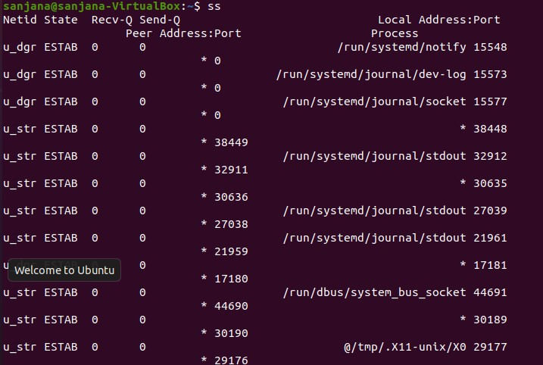

5. Package Management and Updates:

* `apt` (Debian/Ubuntu): Package management commands for updates and installations.

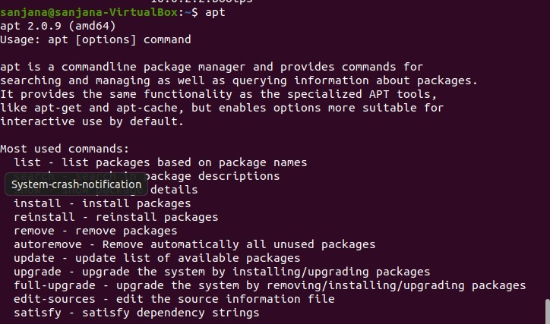

* `unattended-upgrades`: Automatically install security updates.



6. Intrusion Detection and Monitoring:

* `ps`: Display information about running processes.

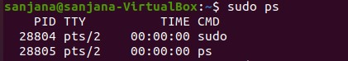

* `top` or `htop`: Display real-time system resource usage.

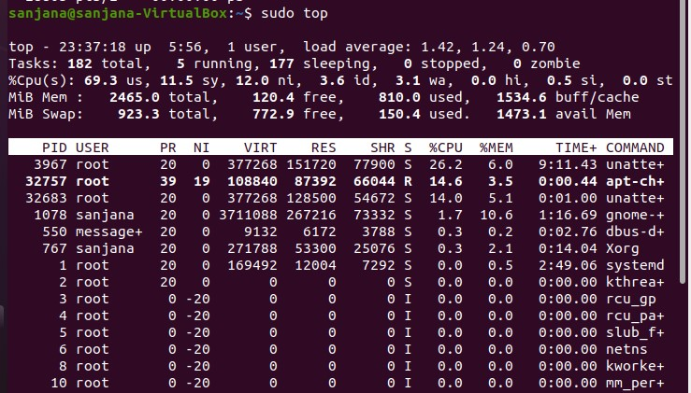

* `netstat` or `ss`: Display network statistics and connections.

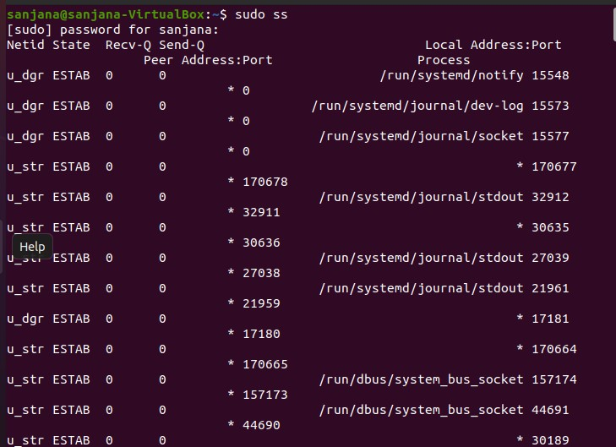

7. Secure Communication:

- `ssh`: Secure shell for remote access.

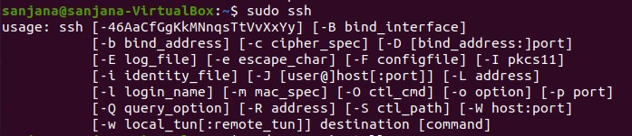

8. Security Scanning:

- `nmap`: Network scanning tool to discover open ports and services.

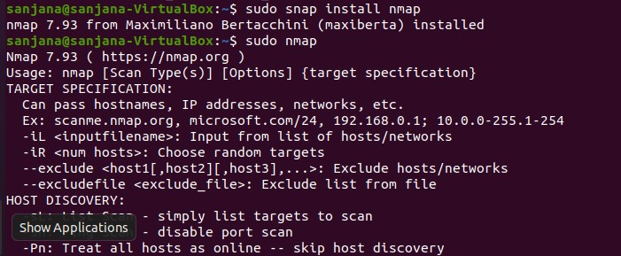

9. Logs and Monitoring:

- `journalctl`: View system log messages (systemd-based systems).

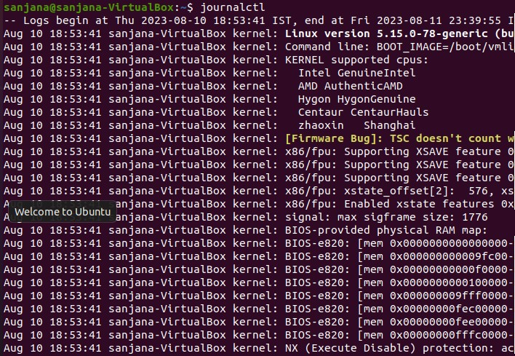

**Q2. Administration of users, password policies, privileges and roles using any platform.**

Platform used - **MySQL**

Login to root user – admin profile

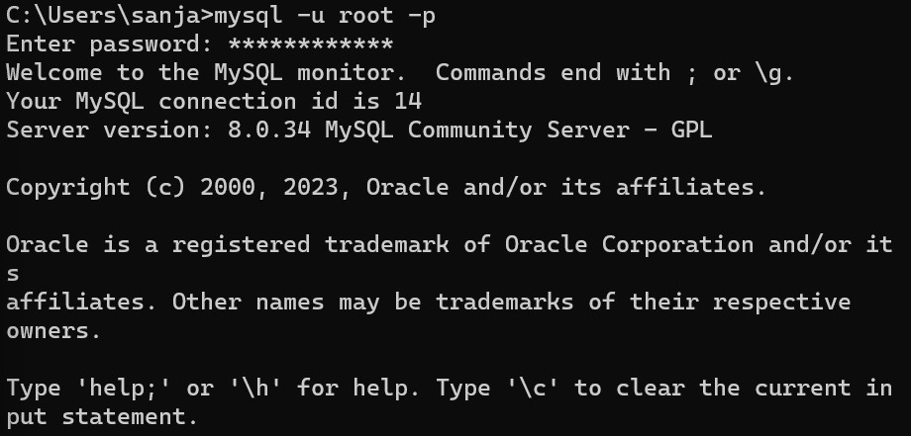

Creating user – sanjana

We have several options when it comes to choosing our user’s authentication plugin.

The auth_socket plugin can be convenient, as it provides strong security without requiring valid users to enter a password to access the database. But it also prevents remote connections, which can complicate things when external programs need to interact with MySQL.

If we do not specify any authentication plugin, the system goes with caching_sha2_password by default.



Creating db – sanjanadb

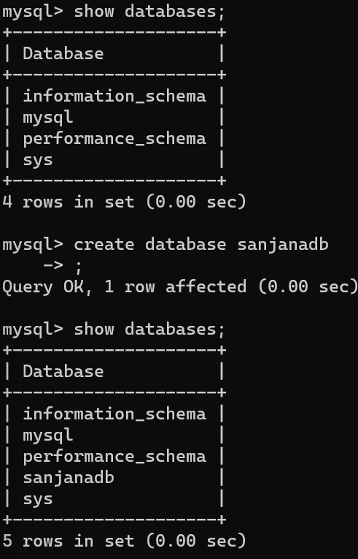

Now, listing all the users –

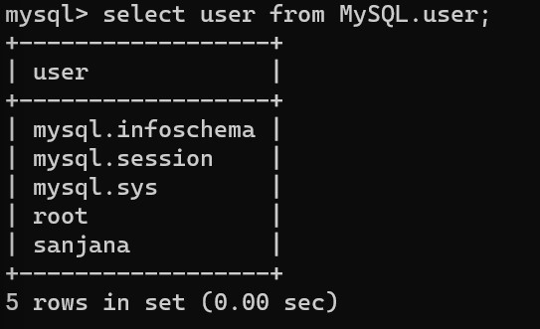

Now, granting privileges to user – sanjana

MySQL supports global ( *.*), database ( database.*), table ( database.table) and column levels of privileges.



Granting the user to create, alter, drop, insert, update the table in the database and also select, references, reload privileges.

We can give many other privileges also.

For ex –

We can grant all the privileges of root user to fellow user as well by command –



Now to reload the grant tables to ensure that the new privileges are put into effect: We pass the command –

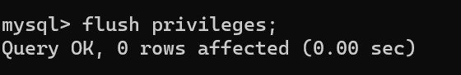

Now to know the grants of user we do –

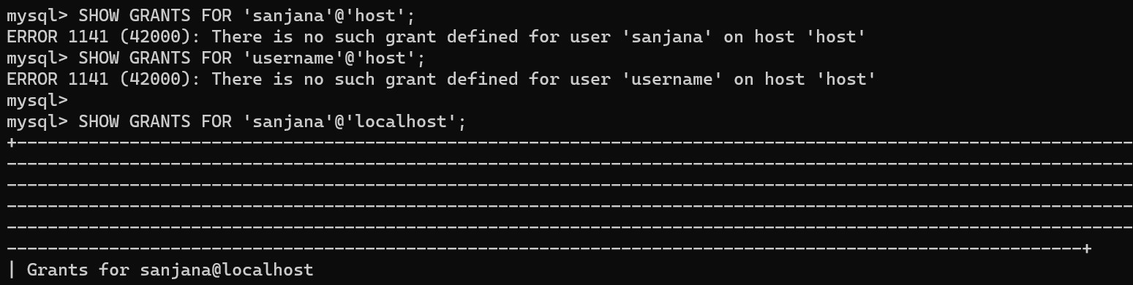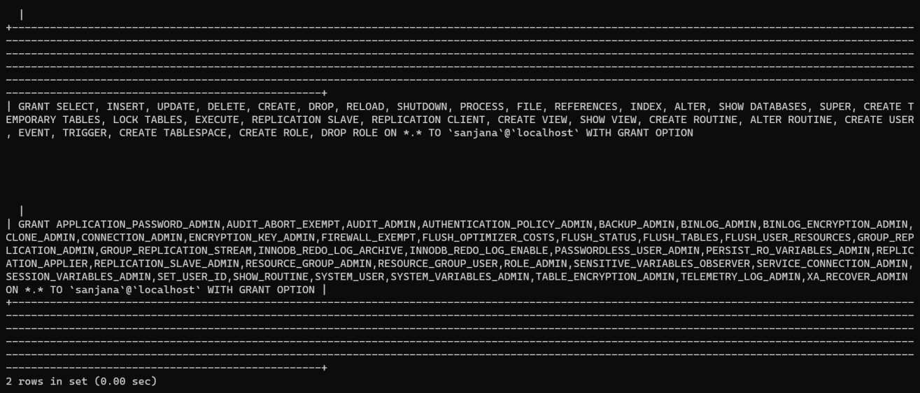

To grant all the privileges –



Now revoking –

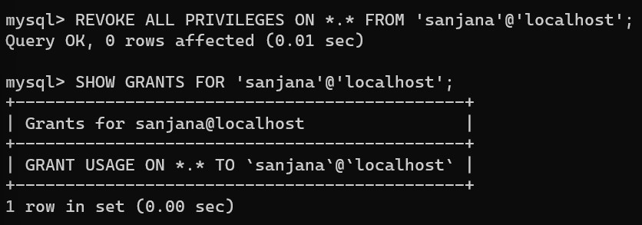

Dropping user –

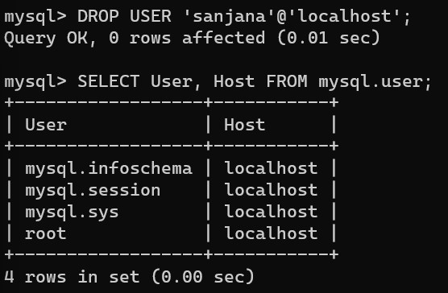

SLOT: L57+L58

CLASS NO: VL2023240104743

**CSI3022 - Cyber Security and Application Security**

**DIGITAL ASSESSMENT – 2**

# A) Eavesdropping Attacks and its prevention using SSH

1. Update your Ubuntu Server to the latest version with all the updated configurations.

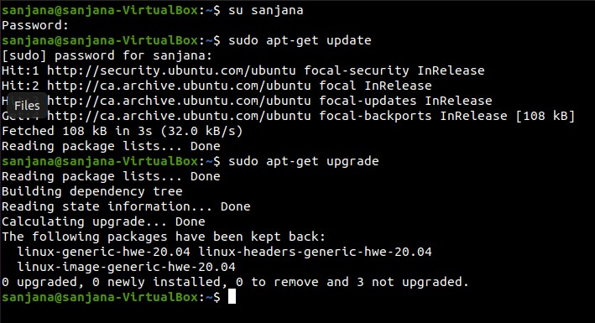

1. Install SSH Server in your Ubuntu Server.

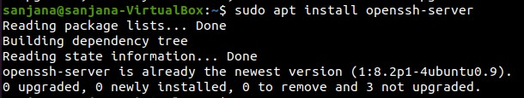

1. Open SSH Server Config files to enable PasswordAuthentication and Add a new user for connection to the ubuntu server using SSH.

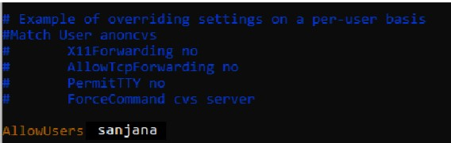

1. Check the SSH status.

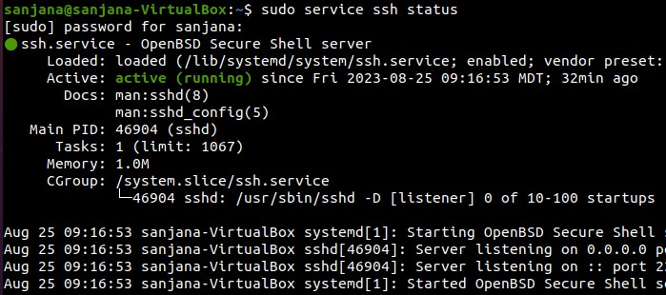

1. Start your SSH server.



1. Try fully restarting your SSH server.sudo service

Command



Output



1. Open your Ubuntu configuration file and grant permission for the members of the "sudo" group to run the /usr/sbin/sshd command without entering a password when using the sudo command. Let's break down the components. Command



output

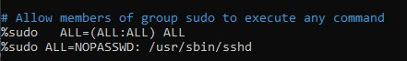

1. Use the ifconfig command to view the ipadress of the Ubuntu Server. Command



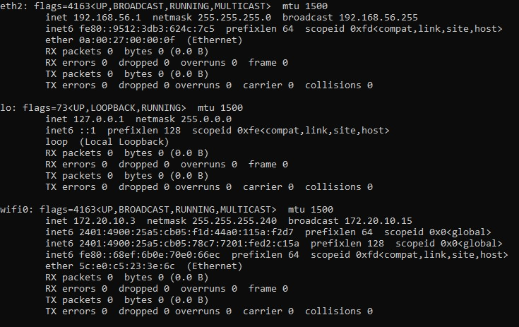

9.Open the Putty tool/Software.

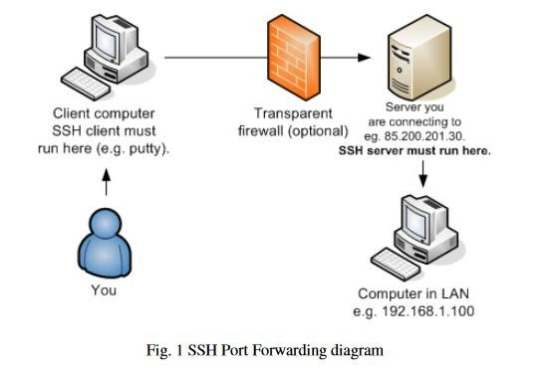

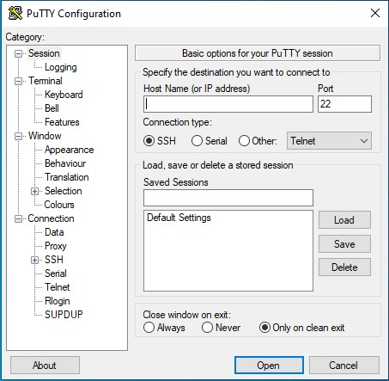

1. Enter the host IP address/Host Name and enter the port number of the Ubuntu Server.

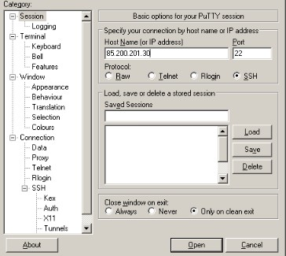

1. Make sure SSH protocol version is 2 and Upstream and Downstream are checked.

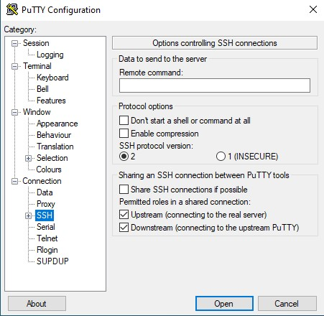

1. Click on Connect, You will get a pop up regarding a Security Alert. Click on Accept/Connect Once to connect to the Ubuntu Server.

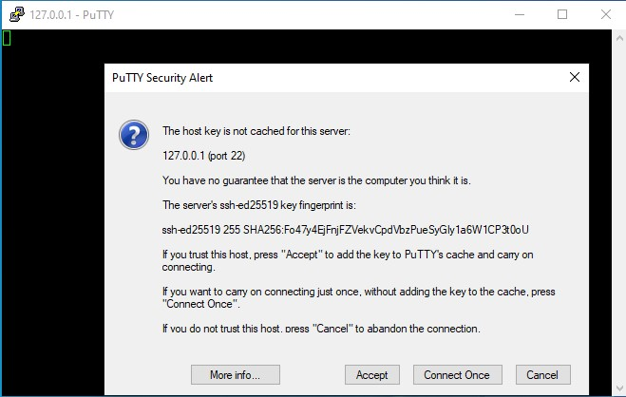

1. The connection is made, enter your Ubuntu credentials.

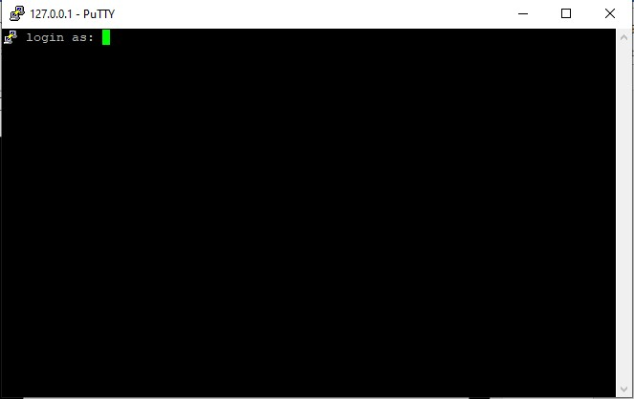

14.after entering your ubuntu credentials , you will be allowed access of the ubuntu Terminal.

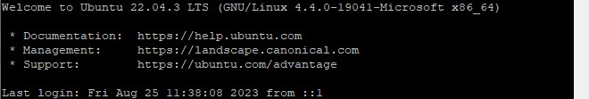

15. perform some commands/operation to check whether your connection is properly connected and works properly.

1. I’m using the **whoami** command to check the username of the ubuntu server using Putty Terminal
2. I’m using the **list** command to list the files in the directory.
3. I’m using the **create** command to create a new text file named as text.txt.

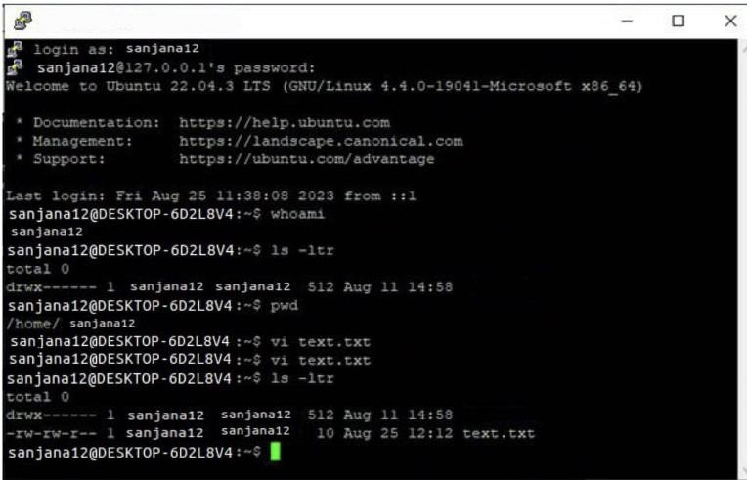

Insert some values into the text file.

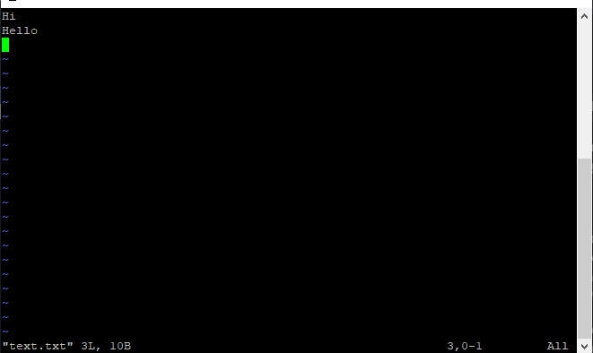

All the above Operations/Commands are done inside the Putty Terminal.

16. Check the above Operations/Commands performed inside the Putty Terminal is reflected inside your Ubuntu Server.

1. I’m using the List command to list the files inside the directory, I can find a text.txt file which was created inside the Putty Terminal.
2. When I open the text.txt file, I can see the values which I inserted into the text.txt file in the Putty Terminal.

Command





# B) Deep Packet Inspection on IP/ICMP Vulnerabilities Part1 .ICMP to test and correct network

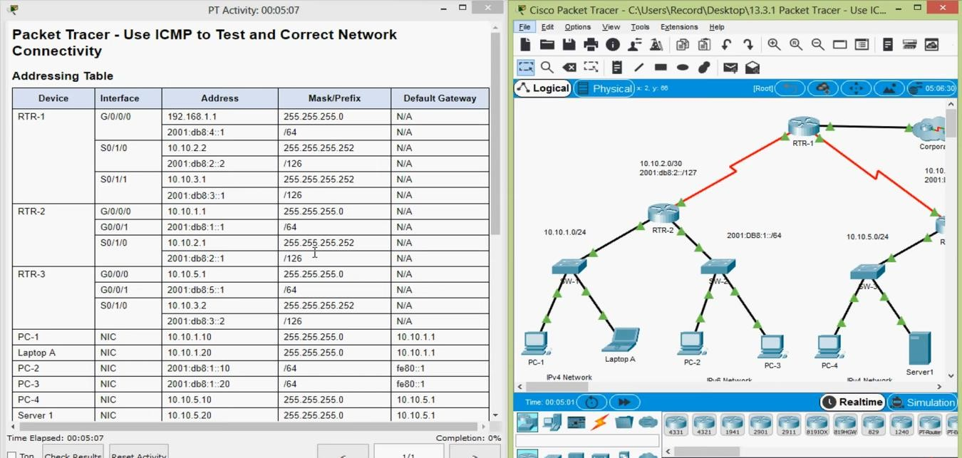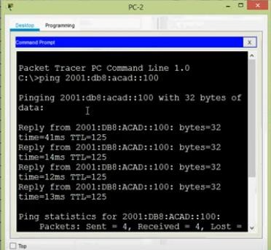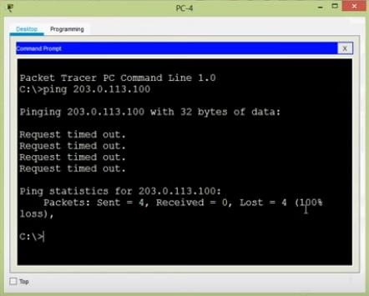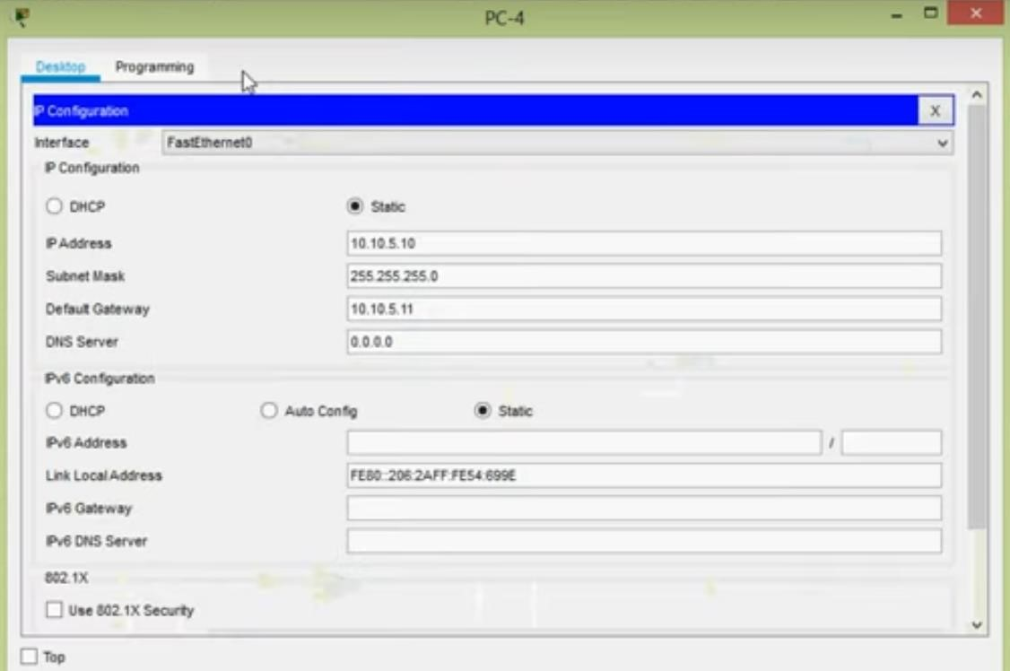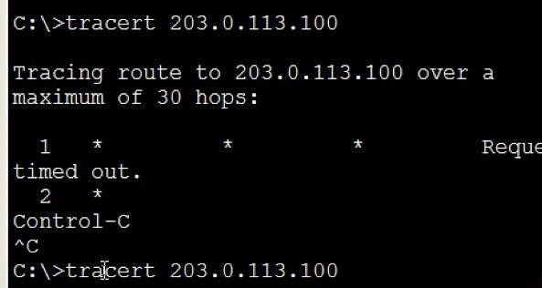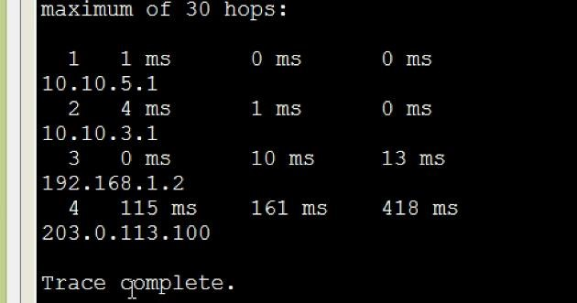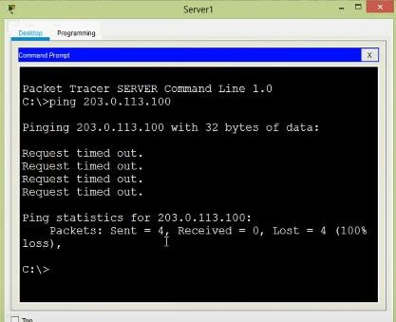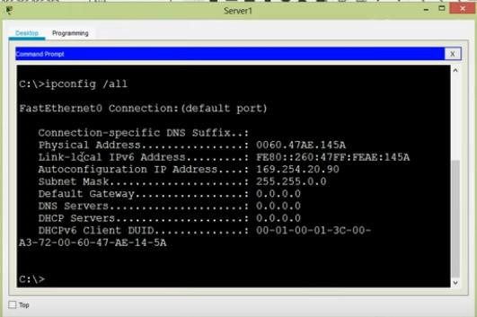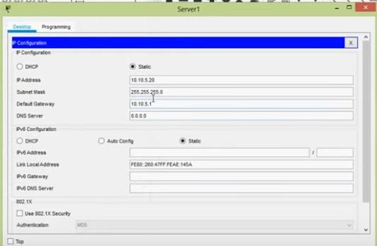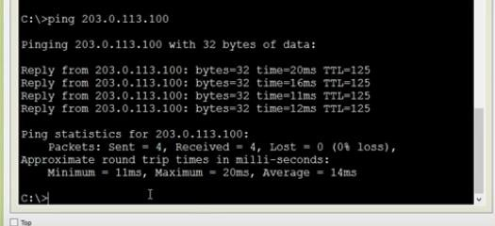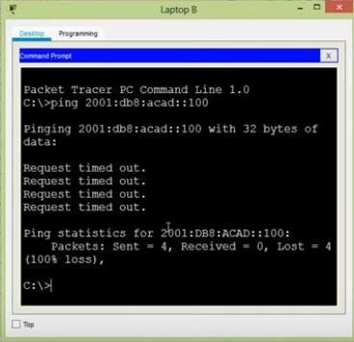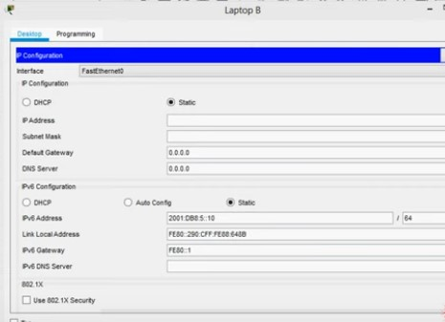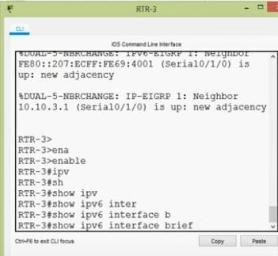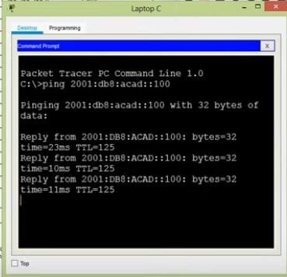

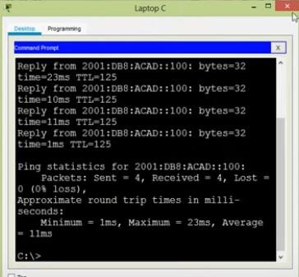

**Part 2:**

Deep Packet Inspection can be done using some software like wireshark. Here we are going with wireshark.

1.At First, we have to create a python code in order to generate the ICMP packets from source IP to destination IP.

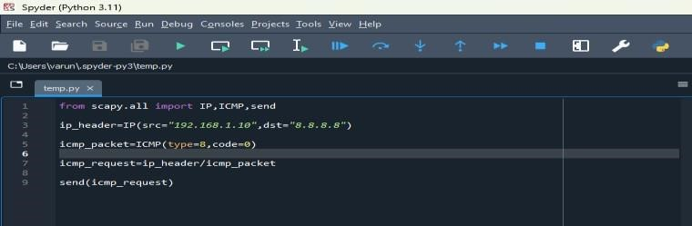

Here 192.168.1.10 is the source IP address of the windows command prompt

2.Now open the wireshark and open the packet capture file over the wifi connection

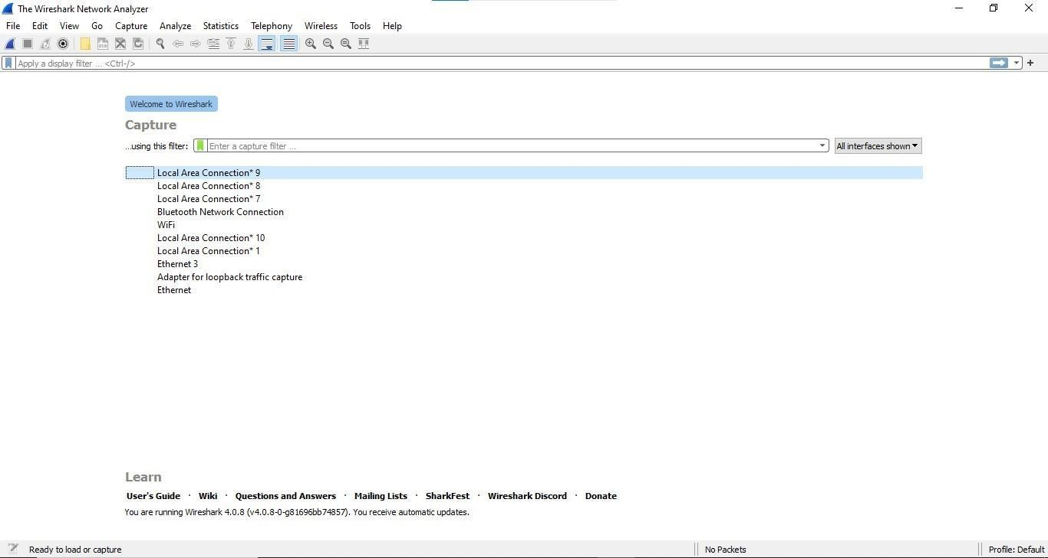

Start the packet capturing in the wireshark

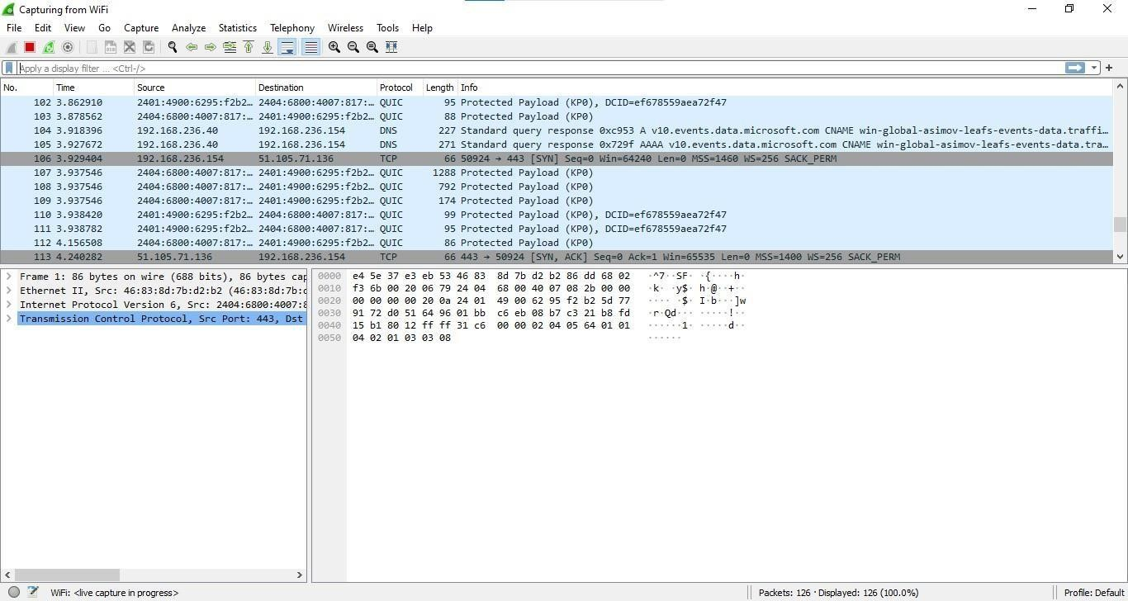

1. Now run the python code to generate the ICMP packet so that wireshark will detect and inspect it

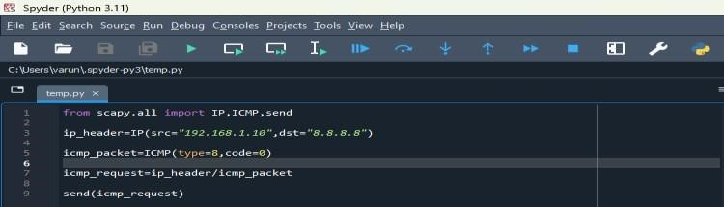

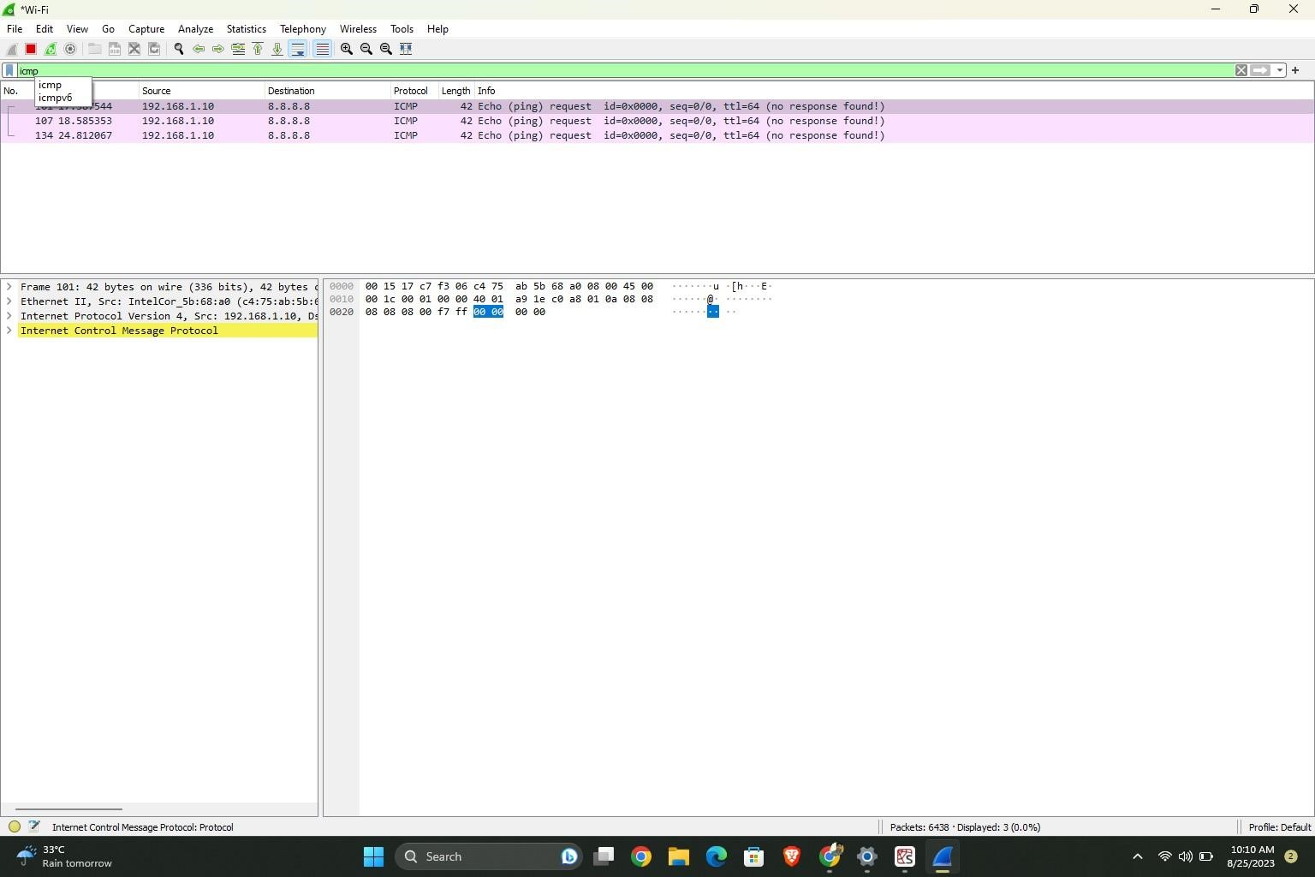

1. Now create a code to generate a ICMP packets which type-3error(Destination Unreachable)

**3 error types:**

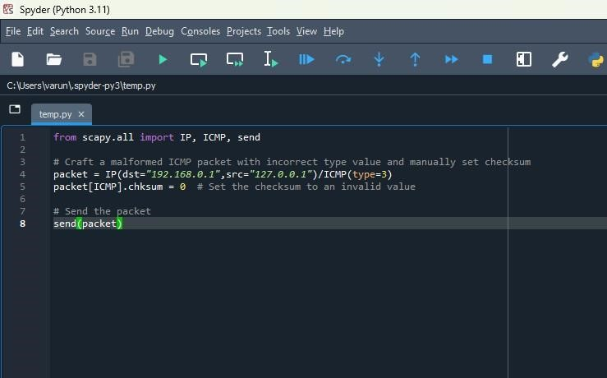

Do the Deep Packet Inspection in wireshark. As we can see the Destination unreachable error has been identified by the wireshark output for 3 error type

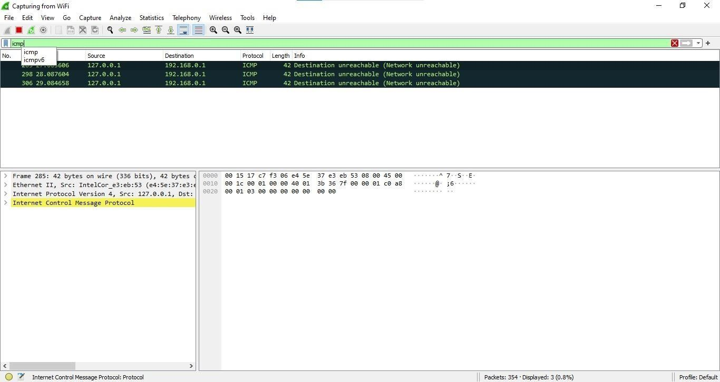

5) Now create a code to generate a ICMP packets which type-5 error(Destination Unreachable)

**5 error type:**

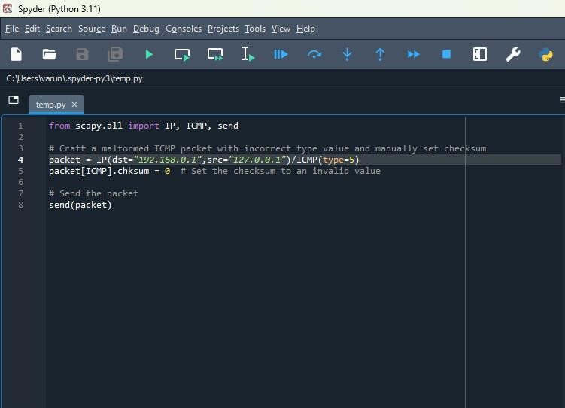

Do the Deep Packet Inspection in wireshark. As we can see the Redirect for network error has been identified by the wireshark

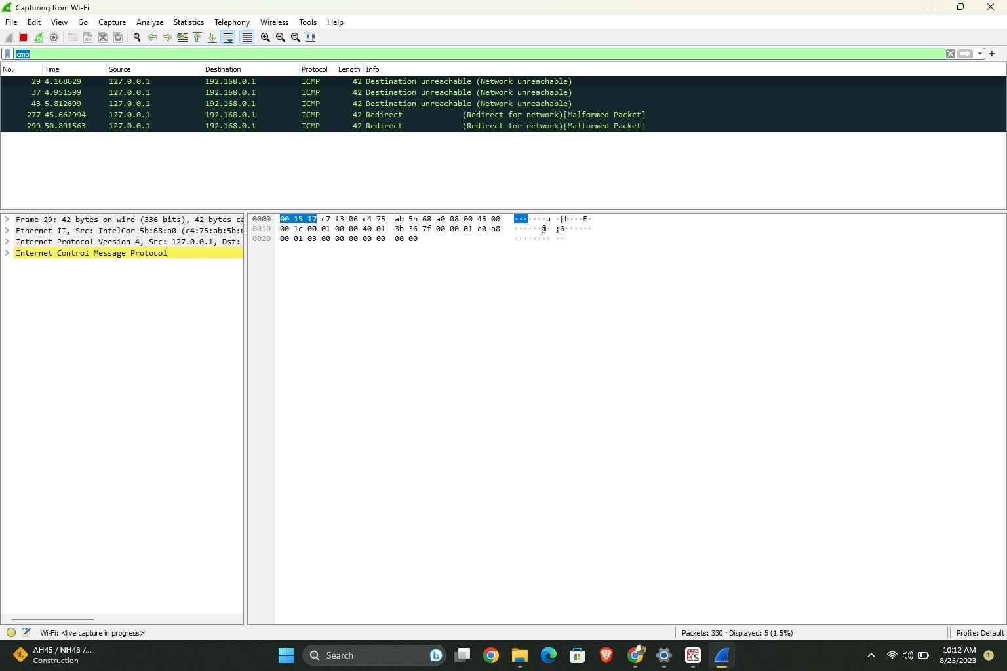

6) Do the Deep Packet Inspection in wireshark. As we can see the Time to leave exceed error has been identified by the wireshark

**11 error type:**

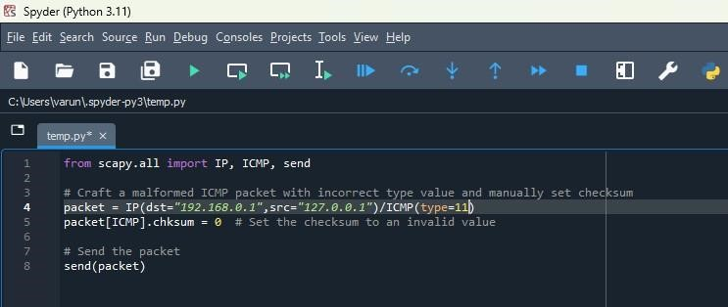

Do the Deep Packet Inspection in wireshark. As we can see the Time to live exceeded error has been identified by the wireshark

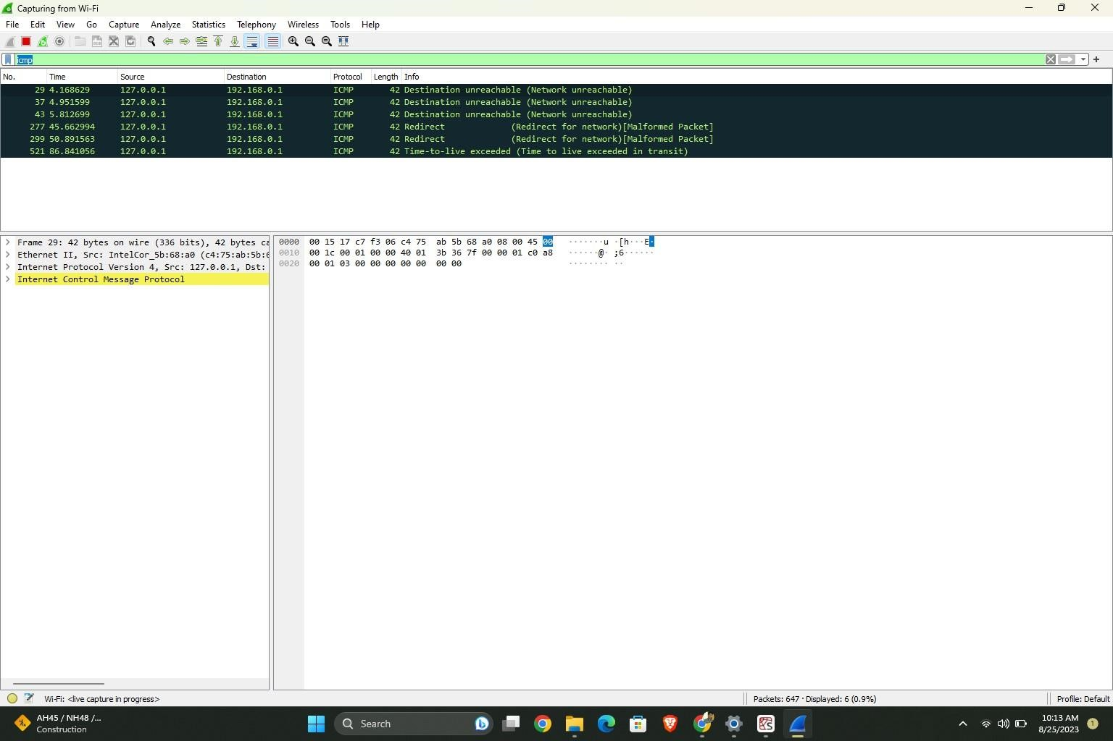

**CYBER SECURITY LAB DA - 3**

DATE – 08/09/2023

# Q1. Deep Packet Inspection on TCP/IP Vulnerabilities

1. Deep Packet Inspection (DPI): Deep Packet Inspection is a technology used for inspecting the contents of network packets at a granular level. It involves analyzing the data payload of packets to understand their structure and content. DPI is often used for various purposes including network security, traffic management, and application optimization.

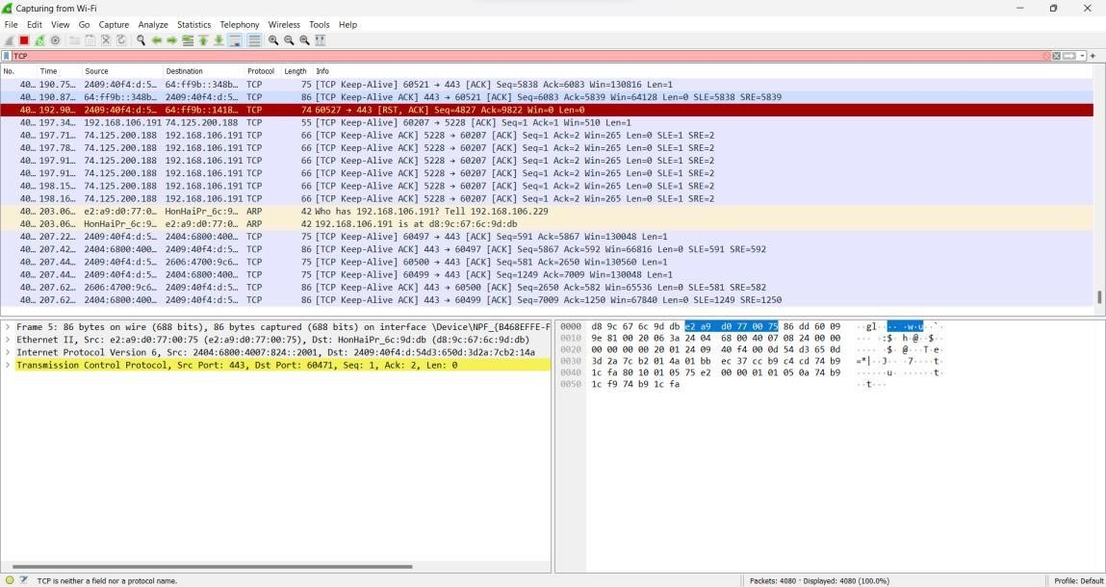

1. TCP/IP, which stands for Transmission Control Protocol/Internet Protocol, is the foundational suite of protocols that underpin the internet. While TCP/IP is essential for internet communication, it is not without its vulnerabilities. Here are some common vulnerabilities associated with TCP/IP:

i. Denial of Service (DoS) Attacks: Attackers can flood a target system or network with an overwhelming volume of traffic, causing it to become unavailable to legitimate users. This can be done by exploiting weaknesses in TCP/IP stack implementations, such as the SYN flood attack that targets the TCP three-way handshake.

|  |  |
| --- | --- |
| ii. | Distributed Denial of Service (DDoS) Attacks: These attacks involve multiple compromised systems (a botnet) that collectively flood a target with traffic, making it nearly impossible to defend against. TCP/IP vulnerabilities can be exploited to amplify the impact of DDoS attacks. |
| iii. | IP Spoofing: Attackers can forge the source IP address in a packet to make it appear as if it comes from a trusted source. This can be used to gain unauthorized access or hide the attacker's identity. |
| iv. | Port Scanning and Enumeration: Attackers use tools to scan for open ports on target systems. Once open ports are identified, attackers may attempt to exploit vulnerabilities in the services listening on those ports. |
| v. | Man-in-the-Middle (MitM) Attacks: Attackers intercept and possibly alter communication between two parties without their knowledge. Weaknesses in the TCP/IP protocols, such as ARP spoofing or DNS spoofing, can be exploited to carry out MitM attacks. |
| vi. | IP Fragmentation Attacks: Attackers can send fragmented IP packets that are reassembled by the target system. Malicious payloads can be hidden in these fragments, bypassing some security measures. |
| vii. | IP Address Exhaustion: The Internet Protocol version 4 (IPv4) has a limited address space, which has led to the exhaustion of available IPv4 addresses. This has necessitated the transition to IPv6, but during this transition, there may be security concerns and vulnerabilities. |
| viii. | BGP Routing Attacks: The Border Gateway Protocol (BGP) is used to manage the routing of data across the internet. Attackers can hijack BGP routes to redirect traffic to malicious destinations or cause network instability. |
| ix. | Packet Sniffing: Attackers can use packet sniffing tools to intercept and analyze network traffic, potentially capturing sensitive information, such as login credentials or confidential data. |
| x. | Weak Authentication and Authorization: Weak or default credentials on network devices or services can be exploited by attackers to gain unauthorized access to systems or data. |
| xi. | Vulnerabilities in Network Services: Many network services and applications are built on top of TCP/IP. Vulnerabilities in these services, such as web servers or email servers, can be exploited to compromise systems. |

xii. Security Misconfigurations: Poorly configured network devices, firewalls, routers, and servers can introduce vulnerabilities into a network that attackers can exploit.

To mitigate these vulnerabilities, it is essential to keep systems and network infrastructure up to date with security patches, employ strong authentication and access controls, use encryption where necessary, and implement intrusion detection and prevention systems (IDS/IPS) to monitor and protect against malicious activities. Additionally, regular security audits and vulnerability assessments are crucial to identifying and addressing potential weaknesses in TCP/IP-based systems.

Performing DPI of TCP/IP packets in Wireshark – Filter the packets using TCP command:

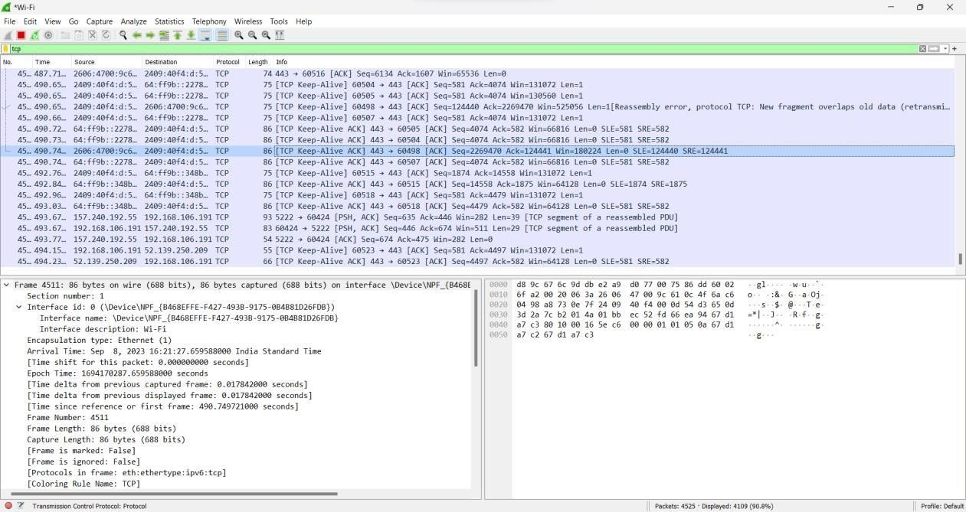

Now double click any packet to inspect:

Frame Information:

Ethernet:

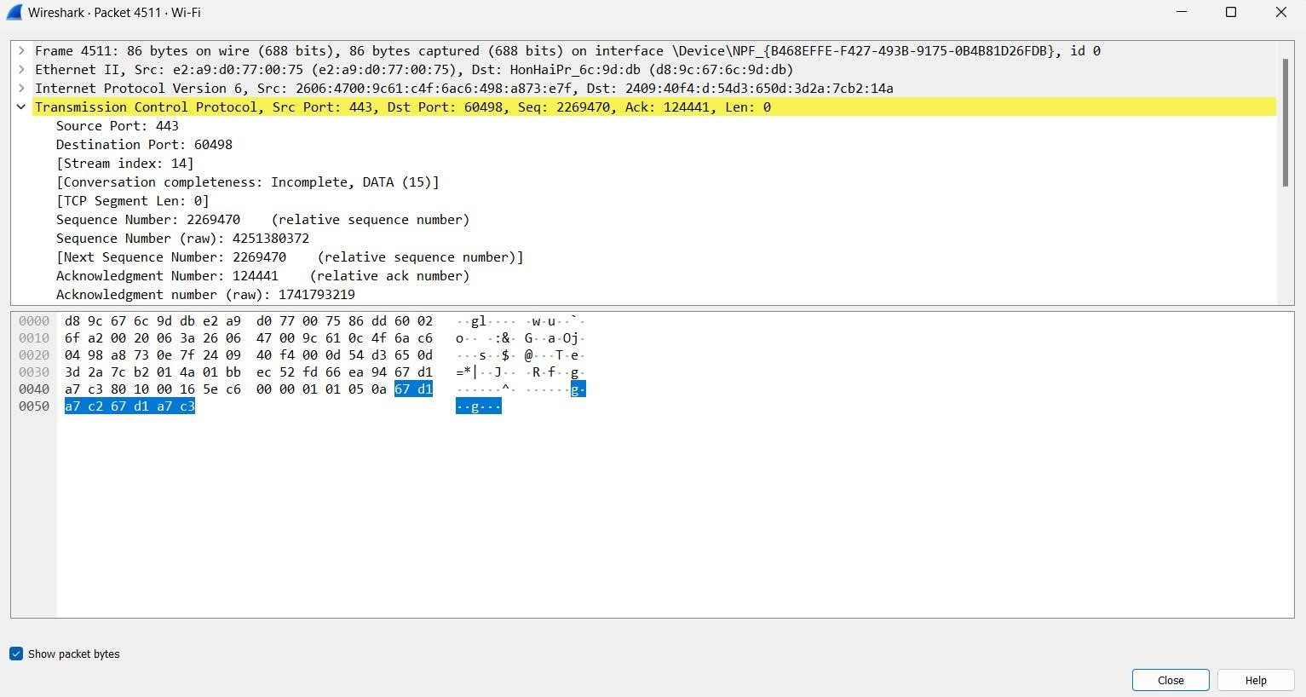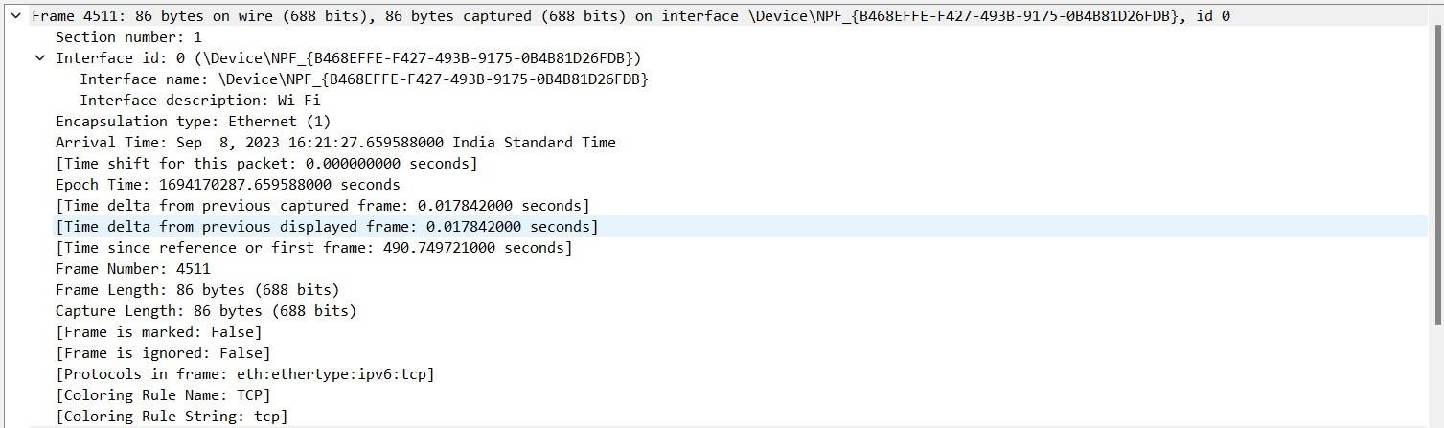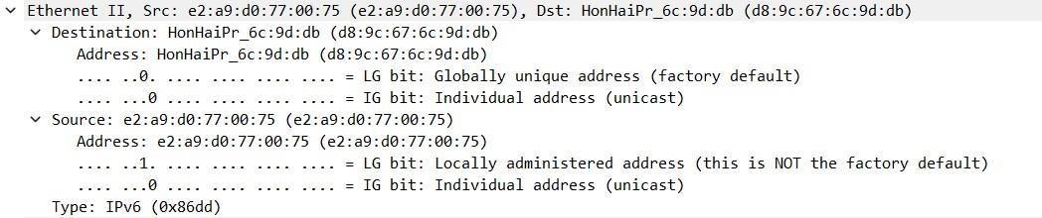

Using IPv6

TCP INSPECTION:

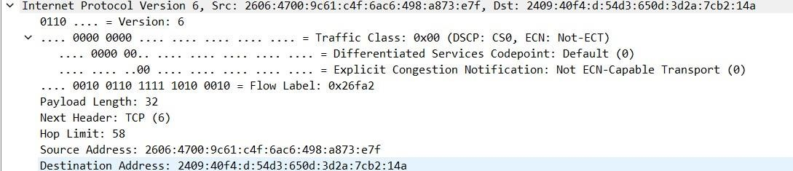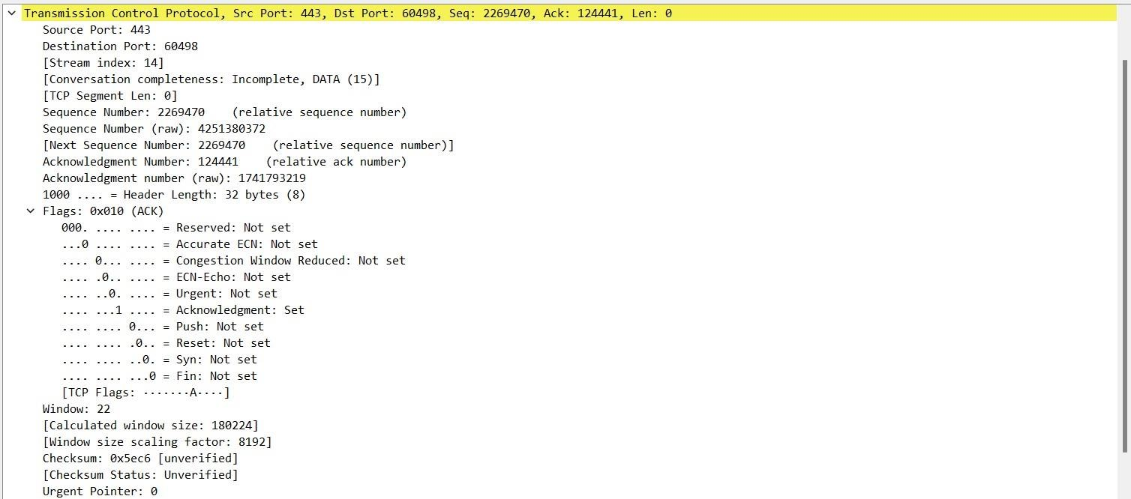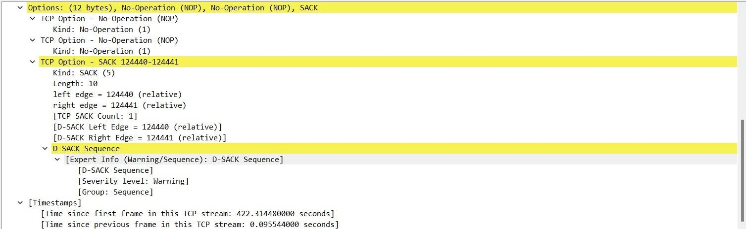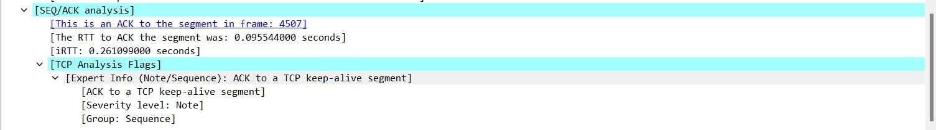

Packet Bytes:

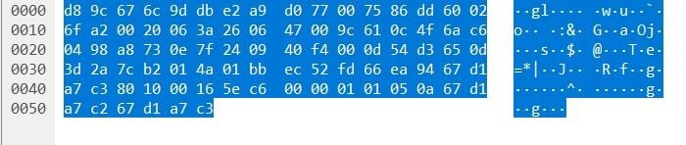

# Q2. Implement your design using Windows Folder structure to activate directory and computer to create security groups that meets your requirement

**Local Security Groups:**

Step 1: Create a Security Group

Open PowerShell with administrator privileges. To do this, right-click the Windows Start button, select

"Windows PowerShell (Admin)" or "Command Prompt (Admin)."

In the PowerShell window, use the following command to create a security group. Replace "GroupName" with the name you want for your security group.

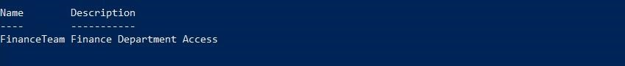

Step 2: Add Users to the Security Group

To add users to the security group, you can use the Add-LocalGroupMember PowerShell command. Replace "GroupName" with the name of your security group and "Username" with the username of the user you want to add.



Step 3: Create a Directory and Set Permissions

* Create a folder where you want to apply the security group permissions. Right-click on the folder location and select "New" > "Folder."
* Give the folder a name and press Enter.
* Right-click the folder and select "Properties."
* In the folder properties window, go to the "Security" tab.

|  |  |
| --- | --- |
| • | Click the "Edit" button to change permissions. |
| • | In the Permissions window, click "Add. |
| • | In the "Enter the object names to select" field, type the name of the security group you created (e.g., "FinanceTeam") and click "Check Names" to validate it. Click "OK" when done. |
| • | With the security group selected, set the desired permissions (e.g., "Read & execute," "Write," etc.) for the group members by checking the appropriate boxes in the "Permissions for [SecurityGroupName]" section. |
| • | Click "Apply" and then "OK" to save the changes. |

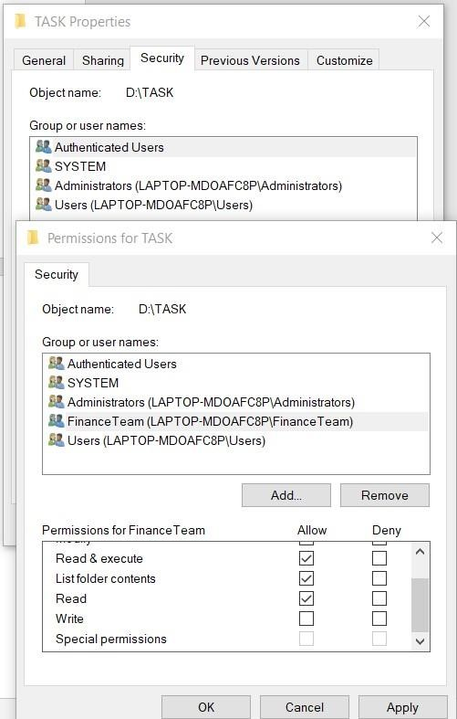

CSI3022-Cyber Security and Application Security

Lab Assessment-4

A) **Basic defensive practice skills against malicious SQL injection attacks in Mobile software development**

**Step 1: Create a Web Page consist of the form for input getting username and password for the database.**

**Step 2: Create a database logindb and create a table users with the username and password columns**

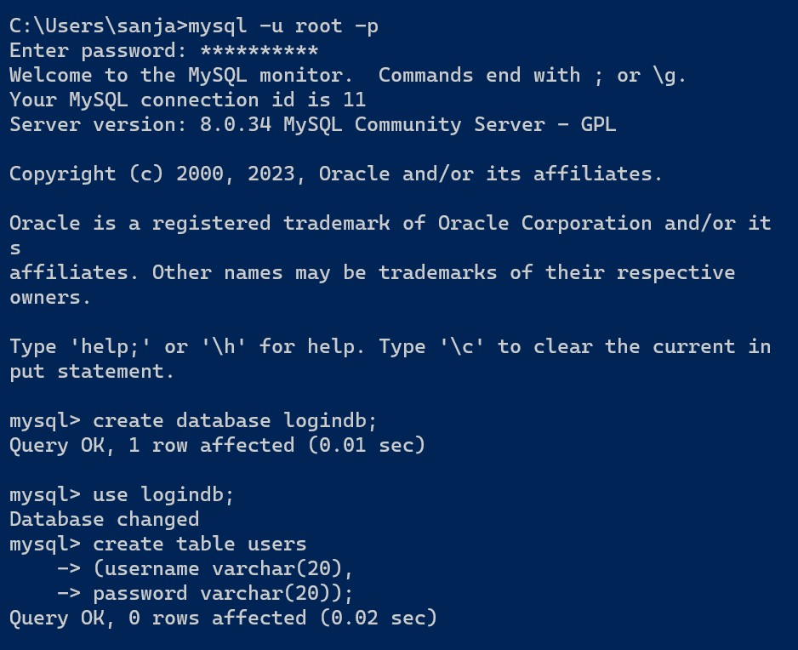

**Step 3: Insert some values for the users table using insert query**

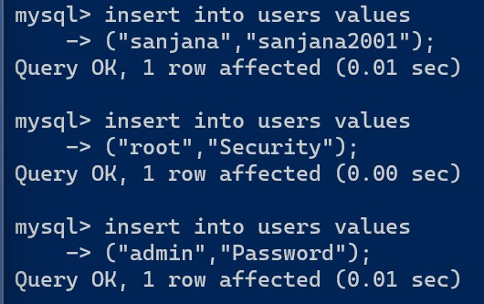

**Step 4:Check the values in the user table**

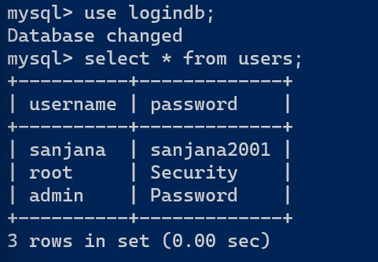

**Step 5: Code the servlet for the functioning for the web page. This servlet connects the databases with the web page and establishes the secure connection between them.**

public class NewServlet extends HttpServlet {

String str;

public int databasecon(String user,String pass)

{

try{

Class.forName("com.mysql.cj.jdbc.Driver");

Connection

con=DriverManager.getConnection("jdbc:mysql://localhost:3306/logindb","root","Divak ar@2003");

String query="SELECT * FROM users WHERE username='" + user + "' and password

= '" + pass + "'";

Statement stmt=con.createStatement();

ResultSet res=stmt.executeQuery(query);

if(res.next())

{

return 1;

}

return 0;

}

catch(Exception e)

{

str=e.getMessage(); return -1;

}

}

protected void doGet(HttpServletRequest request, HttpServletResponse response)

throws ServletException, IOException {

response.setContentType("text/html;charset=UTF-8"); try (PrintWriter out = response.getWriter()) {

String username=request.getParameter("username"); String password=request.getParameter("password");

int flag=0;

flag=databasecon(username,password);

if(flag==0)

{

out.println("<h1>User not found</h1>");

}

else if(flag==1)

{

out.println("<h1>"+username+" has been Found</h1>");

}

else

{

out.println("<h1>"+str+"</h1>");

}

}

}

}

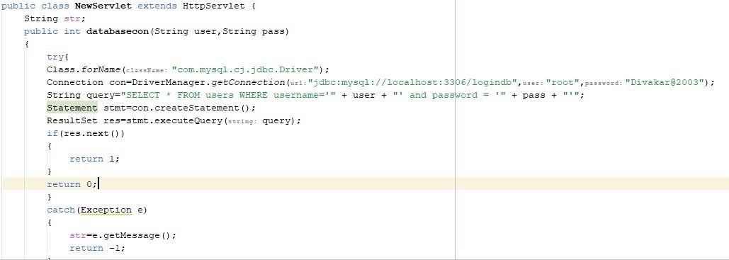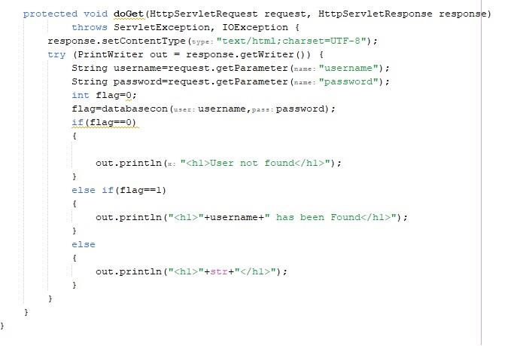

**Step 6: To check the connection between web page and databases, given the correct credentials .**

**Step 7: The User is available in the MySQL Database**

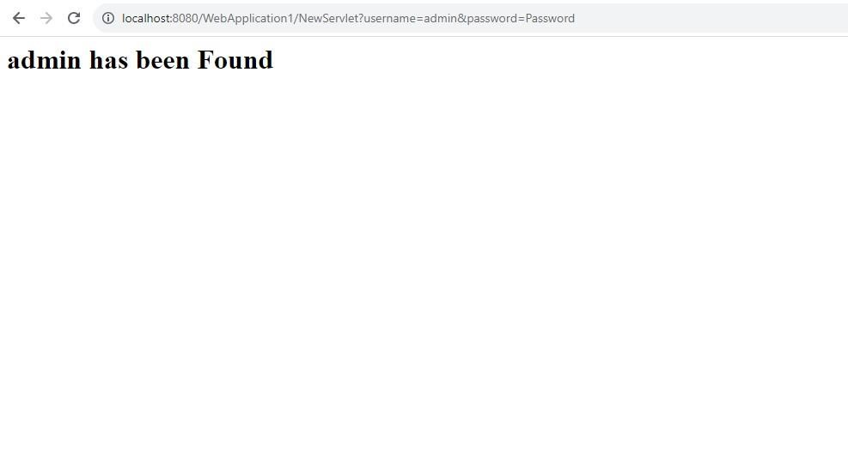

**Step 8: Now give an incorrect credential to check whether the query is working properly.**

**Step 9: The user is not found. Hence, the query is working properly.**

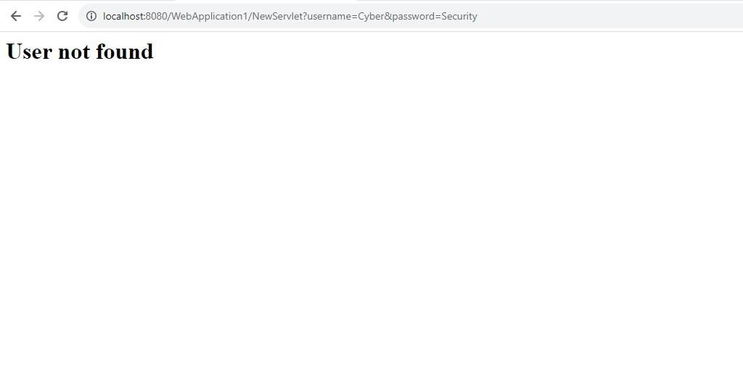

**Step 10: Now perform the SQL Injection for the same unauthorized user and check whether it is working properly.**

**Step11: The SQL Injection attack is successfully has it has obtained the access of the database with unauthorized user.**

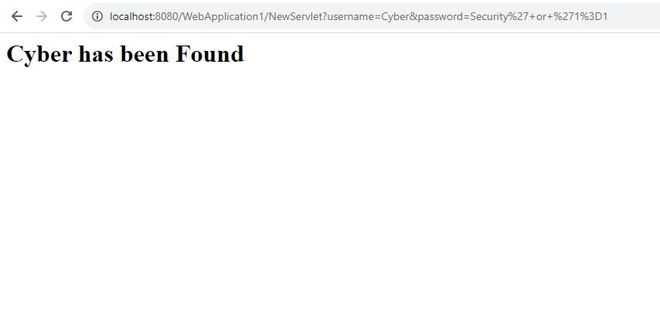

**Step12: Now change the code of JDBC. In particular, change the statement to the preparedStatement. Hence, the preparedStatement will consider the input has one whole string. So the SQL Injection should not work.**

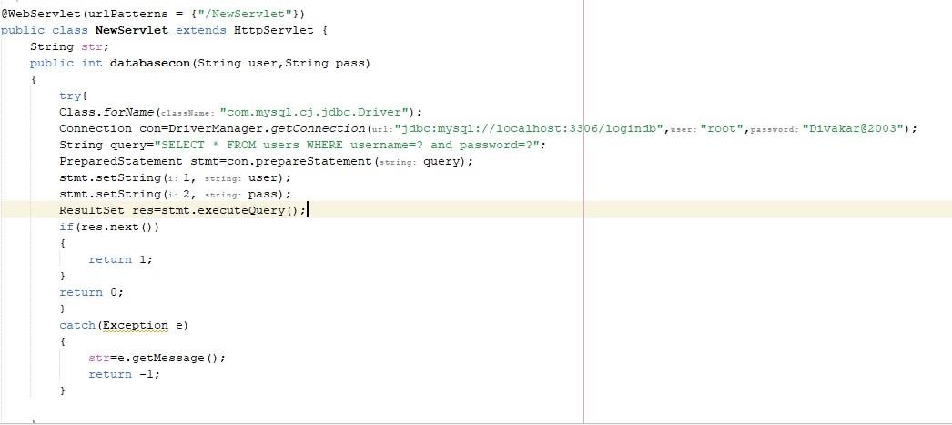public int databasecon(String user,String pass)

{

try{

Class.forName("com.mysql.cj.jdbc.Driver");

Connection

con=DriverManager.getConnection("jdbc:mysql://localhost:3306/logindb","root","Divak

ar@2003");

String query="SELECT * FROM users WHERE username=? and password=?"; PreparedStatement stmt=con.prepareStatement(query); stmt.setString(1, user); stmt.setString(2, pass); ResultSet res=stmt.executeQuery();

if(res.next())

{

return 1;

}

return 0;

}

catch(Exception e)

{

str=e.getMessage();

return -1;

}

}

**Step13:After changing the code, we’re trying the SQL Injection attack again with the same unauthorized user.**

**Step 14: Now the attack is not working. Hence , we have prevented the SQL Injection attack.**

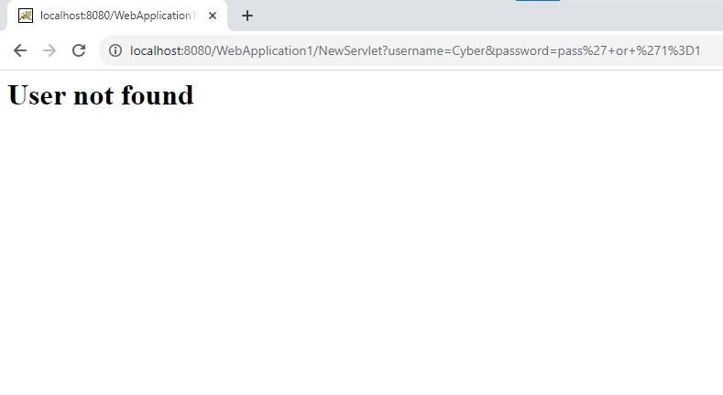

B) **Defense of Brute Force Approach of Gaining Access MySQL Database with Weak Authentication CODE:**

The below code, going to brute force search for the correct password using python function.

If the password has been found, then the “password found” is printed and the particular password is printed.

|  |
| --- |
| password="cyber" def printAllKLength(set, k): n = len(set) printAllKLengthRec(set, "", n, k) def printAllKLengthRec(set, prefix, n, k):  if (k == 0):  if(password == prefix):  print("Password found")  print("The given password is :",prefix) return return for i in range(n):  # Next character of input added newPrefix = prefix + set[i] |
| printAllKLengthRec(set, newPrefix, n, k - 1)      # Driver Code if __name__ == "__main__":  set1 =  ['a','b','c','d','e','f','g','h','i','j','k','l','m','n','o','p','q','r','s  ','t','u','v','w','x','y','z'] k = len(password) printAllKLength(set1,k) |

**OUTPUT:**

After running for many combinations, the program finally found the password given the user. This type of attack is known as brute force attack.

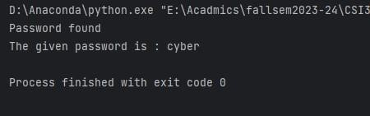

These types of attacks can be prevented by using the counter, which has the limiter value which tells the number of attempts can be made to enter the password. If the value exceeds, then the password needs to be reset again. This type of attacks has been prevented by almost every website

1. Weak Authentication Configuration:

Create MySQL user accounts with weak passwords (for educational purposes only). Ensure that these passwords are easy to guess.

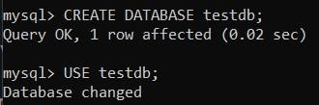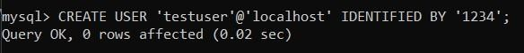

1. Implement Defense Mechanisms:

Implement the security measures mentioned in the previous response, such as rate limiting, firewall rules, and monitoring.

Firewall Rules:

To configure firewall rules, we can use the built-in Windows Defender Firewall with Advanced Security.

Open Windows Defender Firewall with Advanced Security:

Search for "Windows Defender Firewall" in the Start menu and open it.

Click on "Advanced settings" on the left-hand side.

Create Inbound Rules:

In the left pane, click on "Inbound Rules."

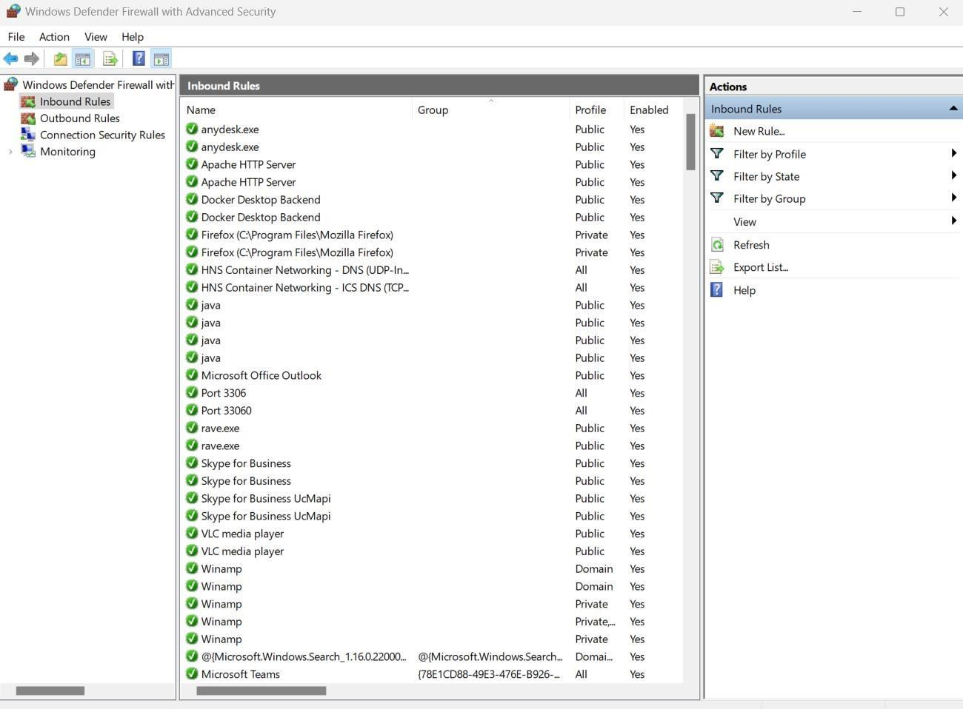

Click on "New Rule..." on the right-hand side.

Follow the wizard to create a new inbound rule to allow MySQL traffic only from trusted IP addresses. Block all other incoming traffic to the MySQL port.

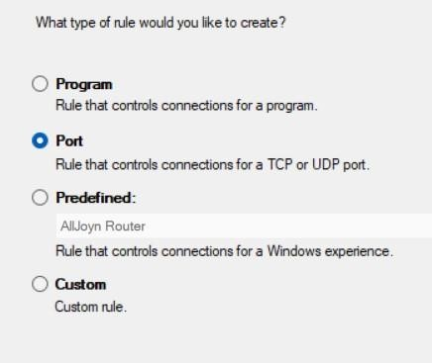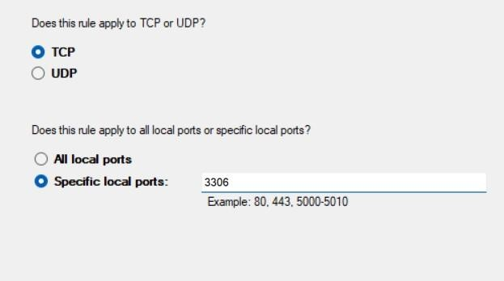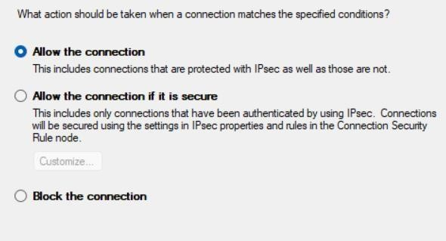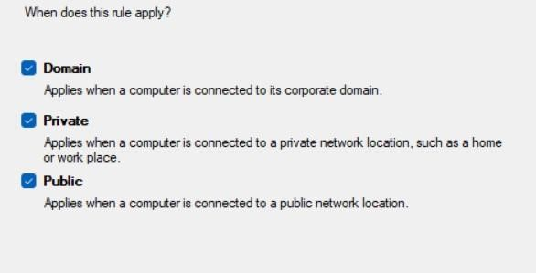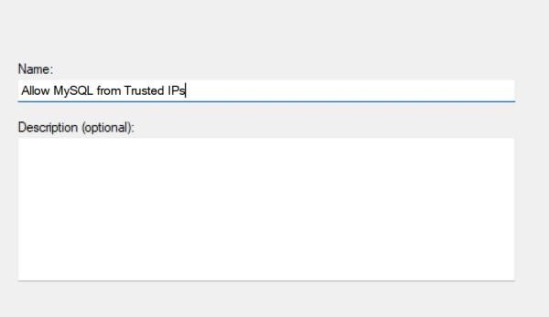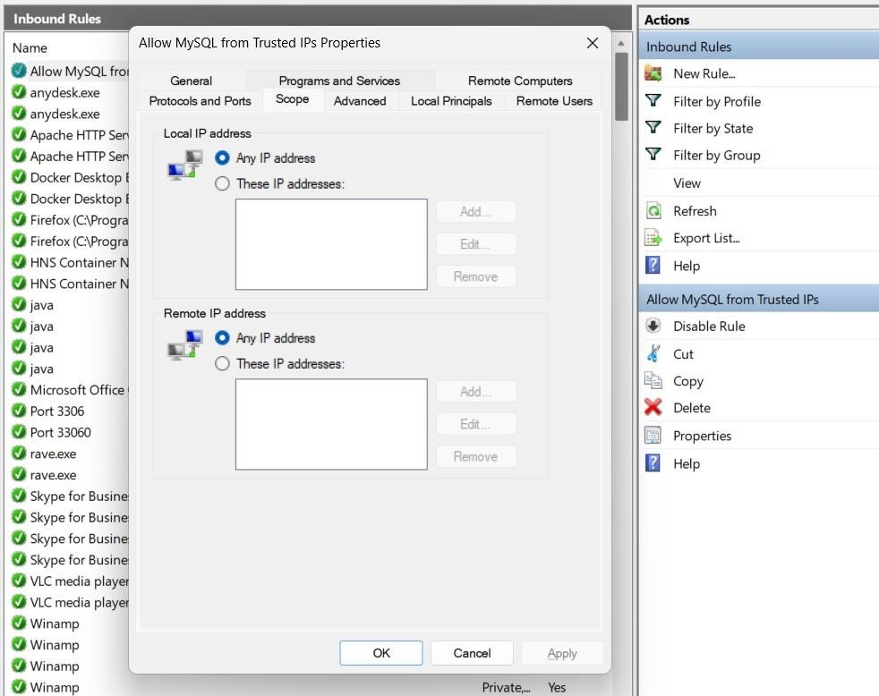

1. Simulate Brute Force Attack:

Use a tool like Hydra or a custom script to simulate a brute force attack on MySQL server. This should be done with explicit permission and only within your controlled environment.

1. Monitor and Log:

Set up monitoring and logging to detect and record brute force attempts.

1. Implement Countermeasures:

Configure your defense mechanisms to respond to brute force attacks. For example, you can implement account lockout or IP blocking after a certain number of failed attempts.

a. Account Lockout:

Local Account Lockout:

Open the "Local Security Policy" editor by searching for "Local Security Policy" in the Start menu.

Navigate to "Account Policies" > "Account Lockout Policy."

Configure settings such as "Account lockout duration," "Account lockout threshold," and "Reset account lockout counter after" to define your account lockout policy.

Apply the settings.

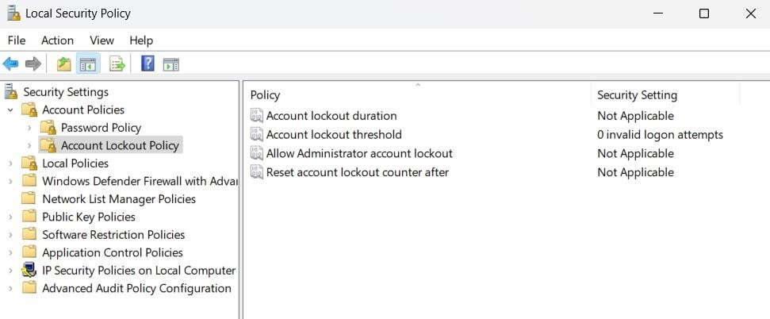 b. IP Blocking:

To block specific IP addresses in Windows 10, you can use Windows Firewall rules:

Create a New Inbound Rule:

Open "Windows Defender Firewall with Advanced Security" by searching for it in the Start menu.

In the left pane, click on "Inbound Rules."

In the right pane, click on "New Rule..." to start the New Inbound Rule Wizard.

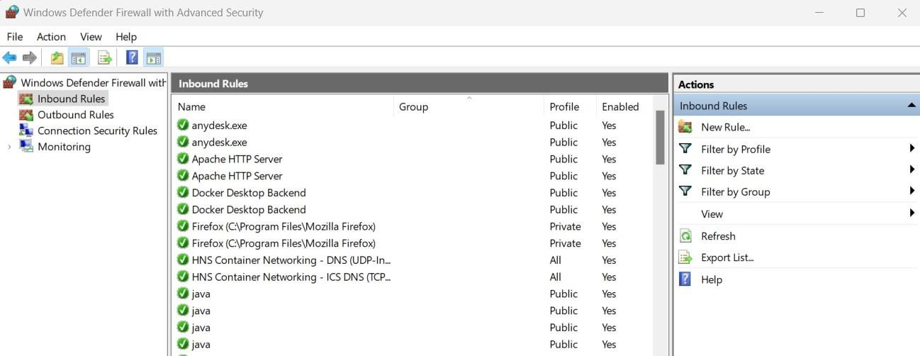

Choose Rule Type:

Select "Custom" and click "Next."

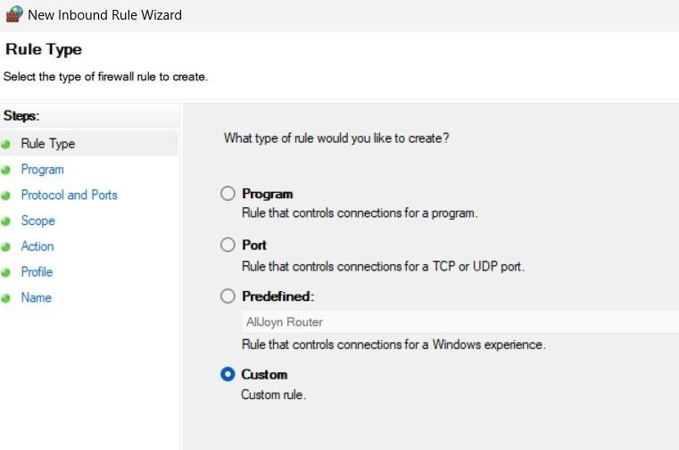

Program:

Leave "This program path" blank and click "Next."

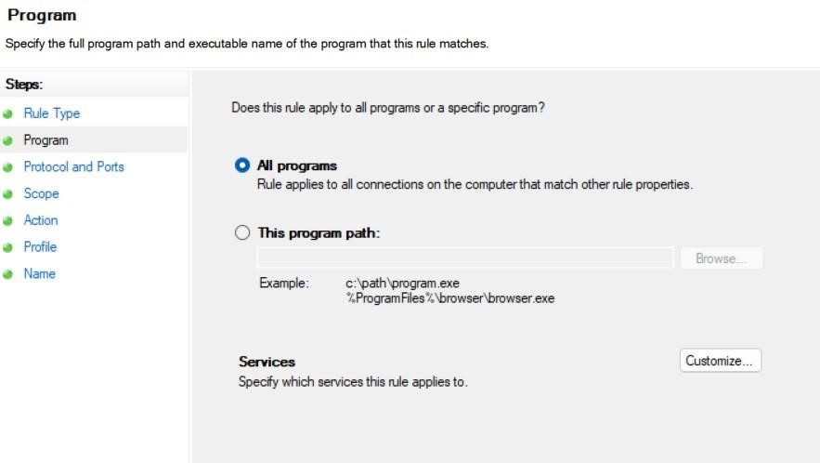

Protocol and Ports:

Leave "All programs" selected and click "Next." Scope:

Under "Which remote IP addresses does this rule apply to?", select "These IP addresses."

Click "Add..." to add the IP addresses you want to block.

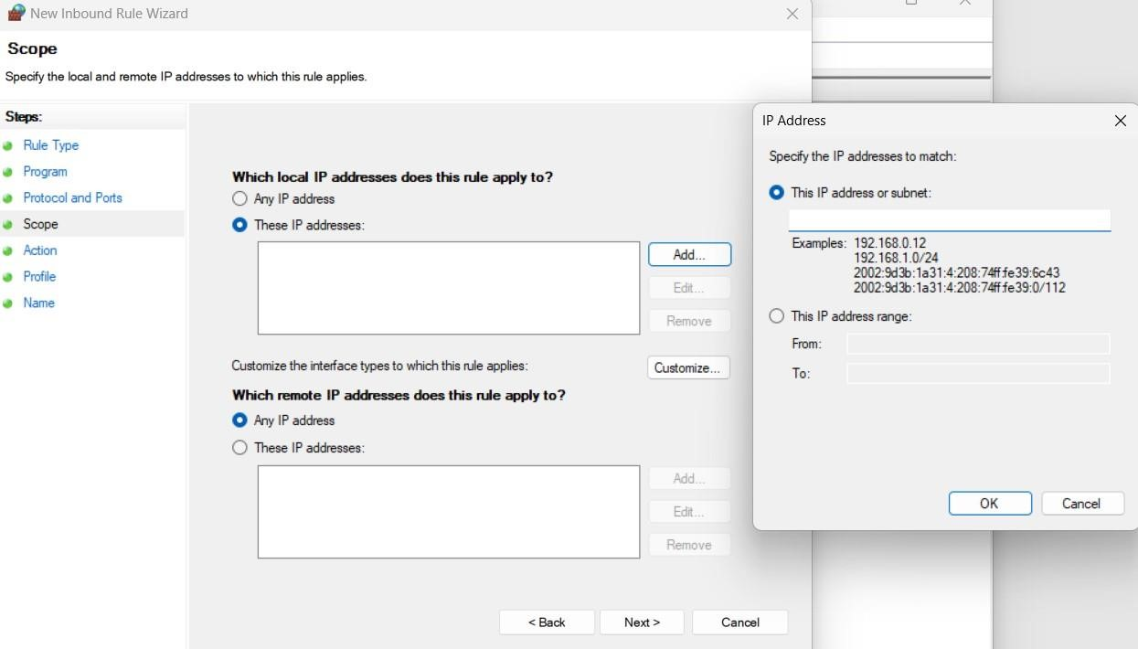

Choose either "This program" or "Any program" as appropriate for your needs.

Action:

Select "Block the connection" and click "Next."

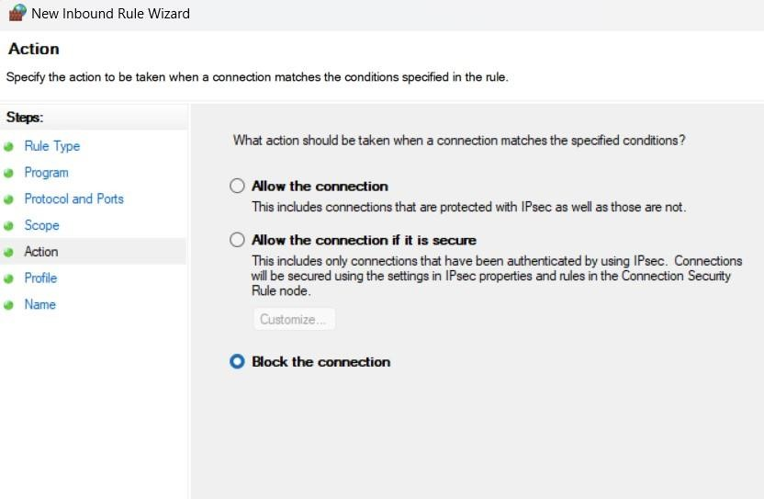

Profile:

Leave all three profiles (Domain, Private, Public) selected if you want to block the IP addresses on all network profiles.

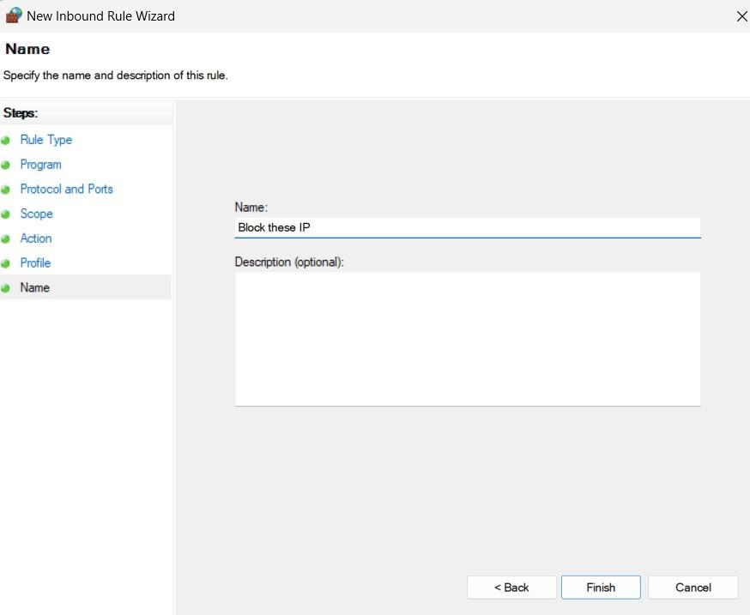

**CYBER SECURITY AND APPLICATION SECURITY LAB**

**ASSIGNMENT – 5**

***Date - October 13, 2023 Submitted to – Dr. Murugan K***

**Q1. Group Policy Management to edit the default domain policy to a specific organization unit.**

Steps:

1. Go to Start > Control Panel, and select Turn Windows features on and off under Programs.
2. In the Add Roles and Feature Wizard window that opens, select Features.
3. Check Group Policy Management, and click Next.
4. Click Install.

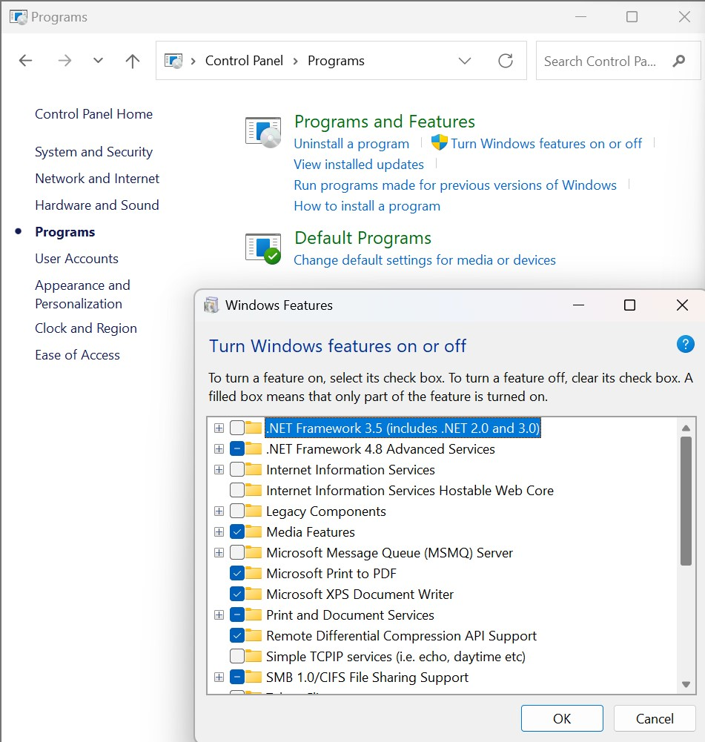

Install Group Policy Management Console (GPMC):



Edit local group policy editor –

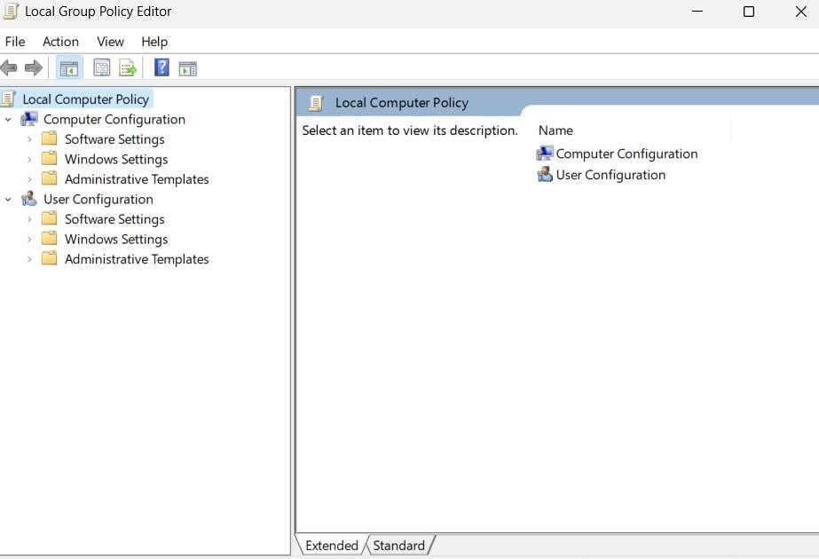

User Configuration > Administrative Template > Start Menu and Taskbar. Click the Standard tab at the bottom of the screen. Then scroll down and double-click on Prevent users from uninstalling applications from Start from the list on the right.

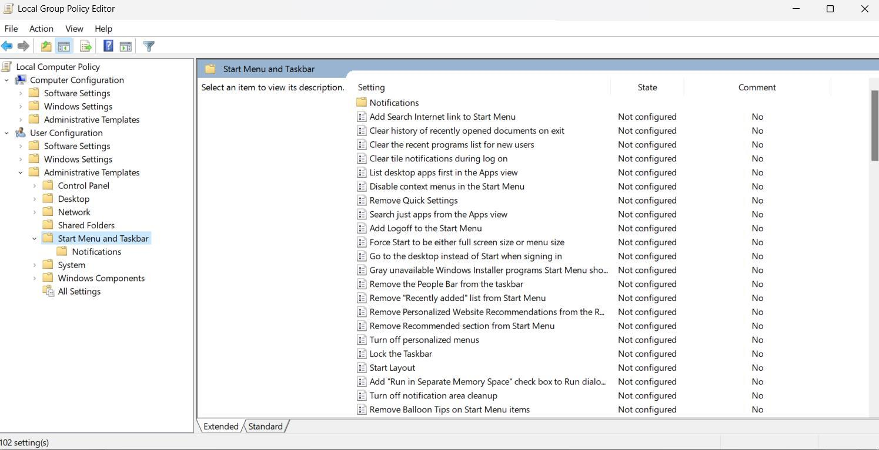

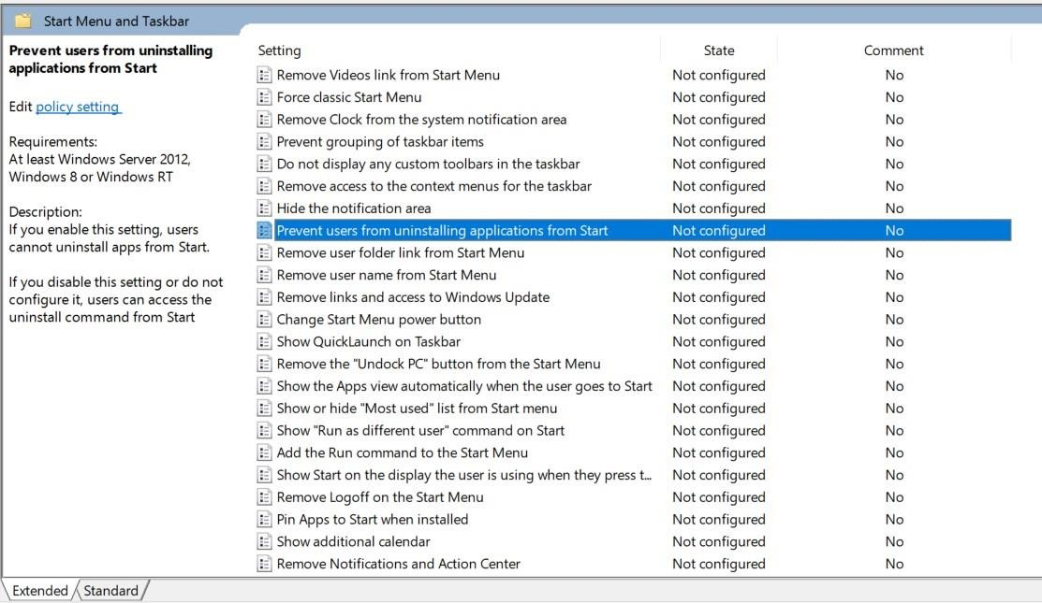

Next, select **Enabled** at the top and then click **OK**

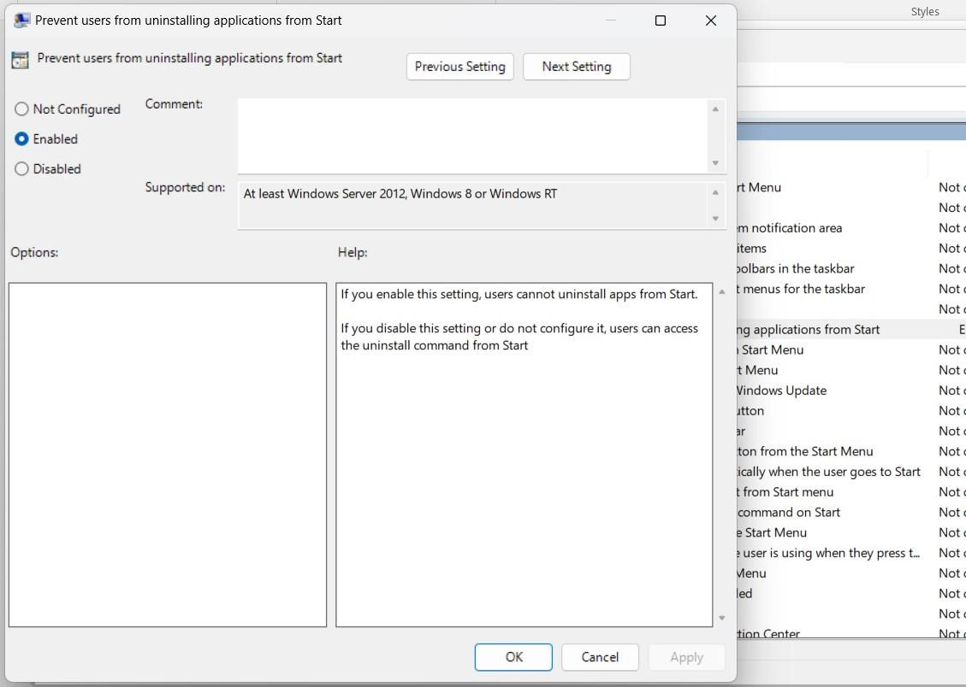

Closeout of Group Policy Editor and hit the **Windows Key** or click the **Start** button. When you right-click on an app in the Start menu, you’ll notice that there isn’t an option listed to uninstall an app anymore.

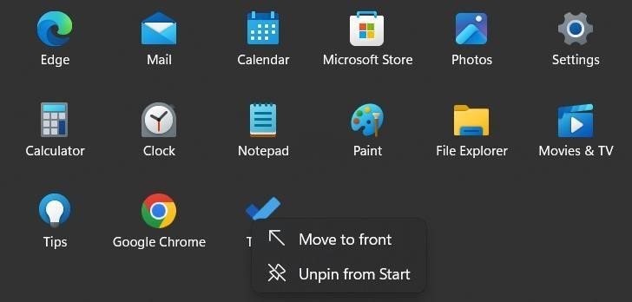

**Q2. Create new rules in Windows firewall to allow the HTTP connection and verify that the new rules allow the HTTP incoming request.**

Go to firewall settings in start menu –

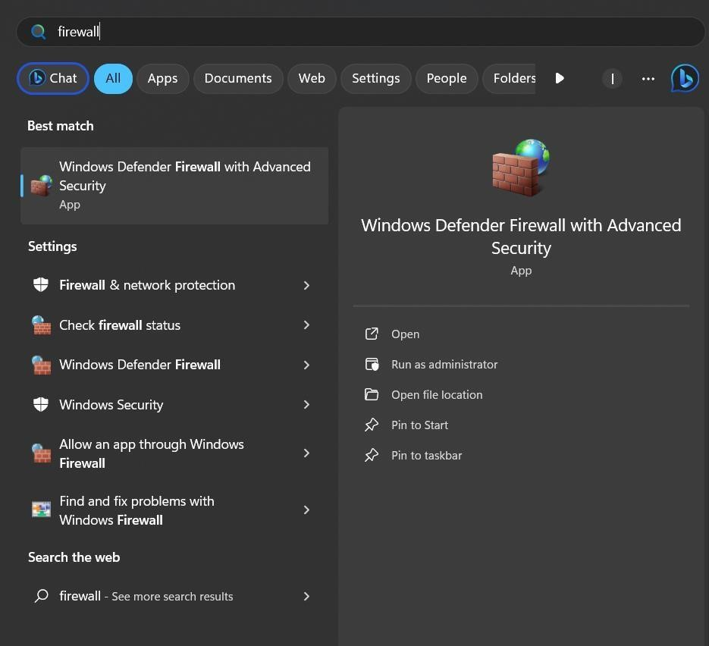

Go to Inbound rules and click on New Rule

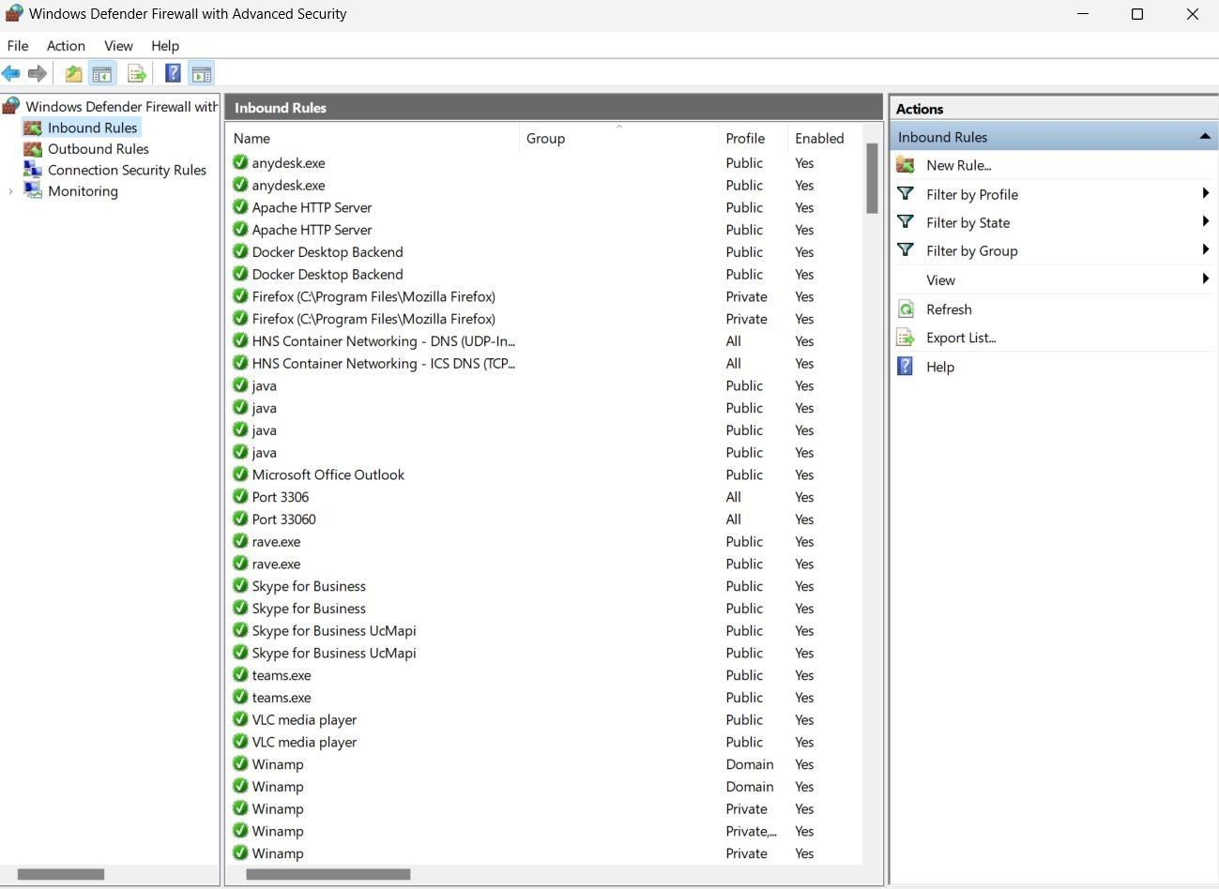

Select the custom rule option and click next

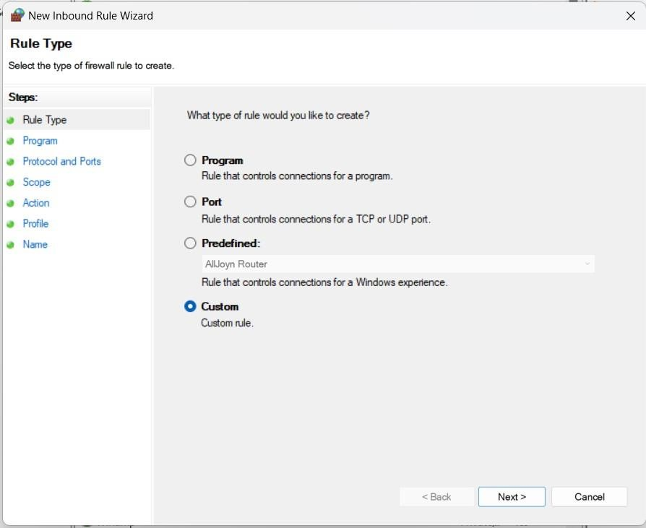

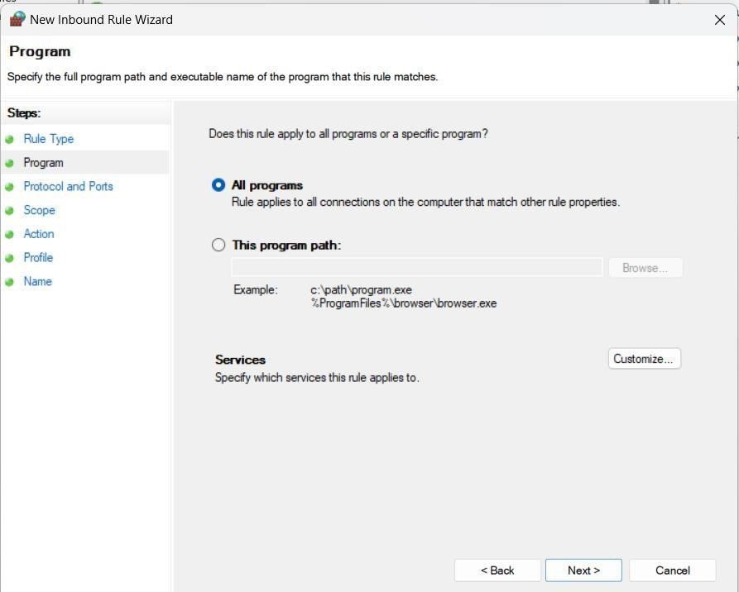

Select TCP as the protocol and select specified local ports as 80 and 443 for HTTP traffic and click Next

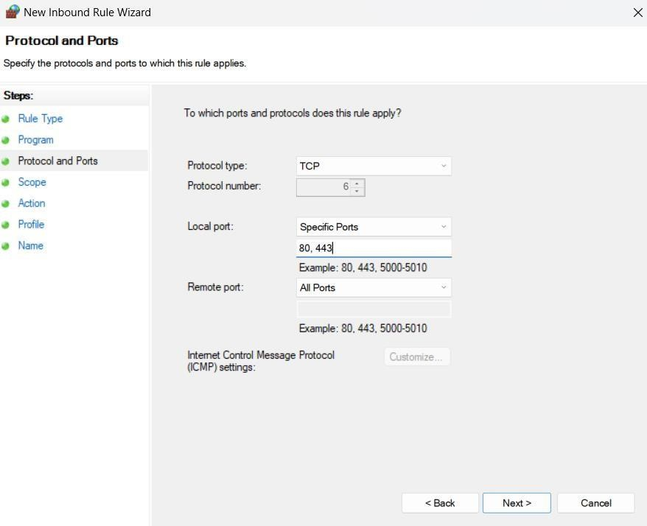

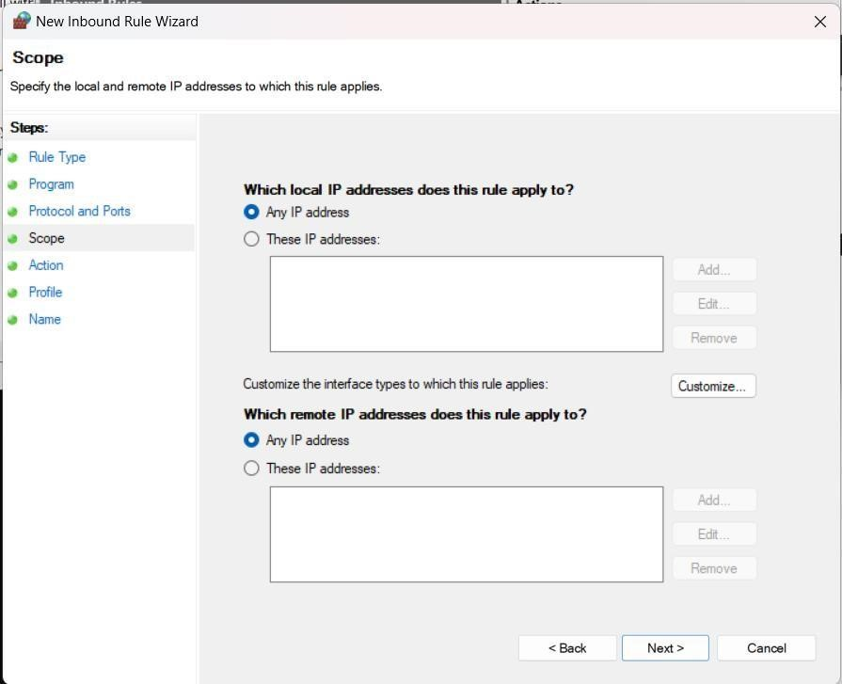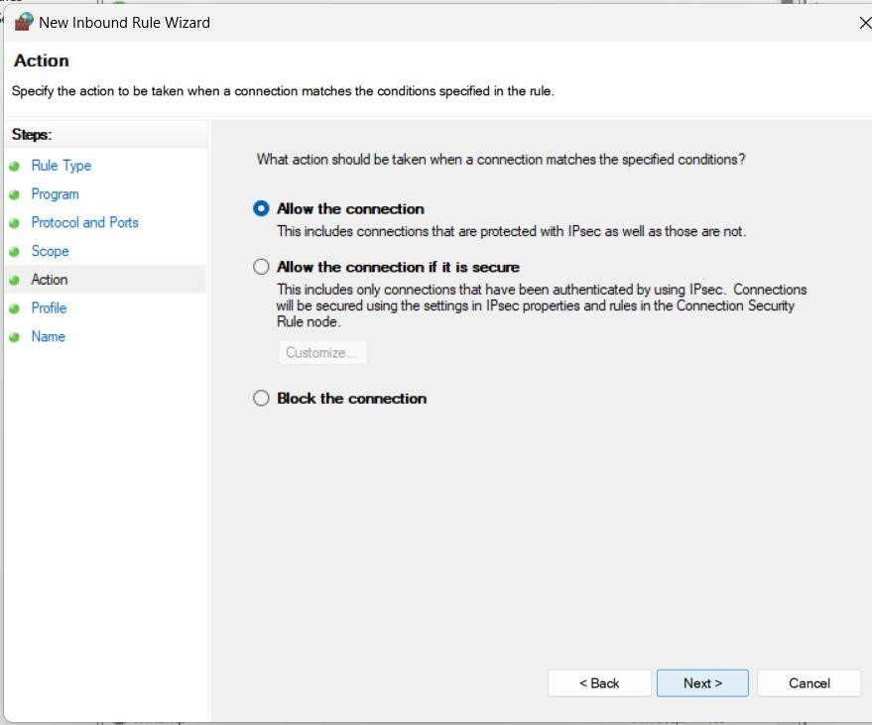

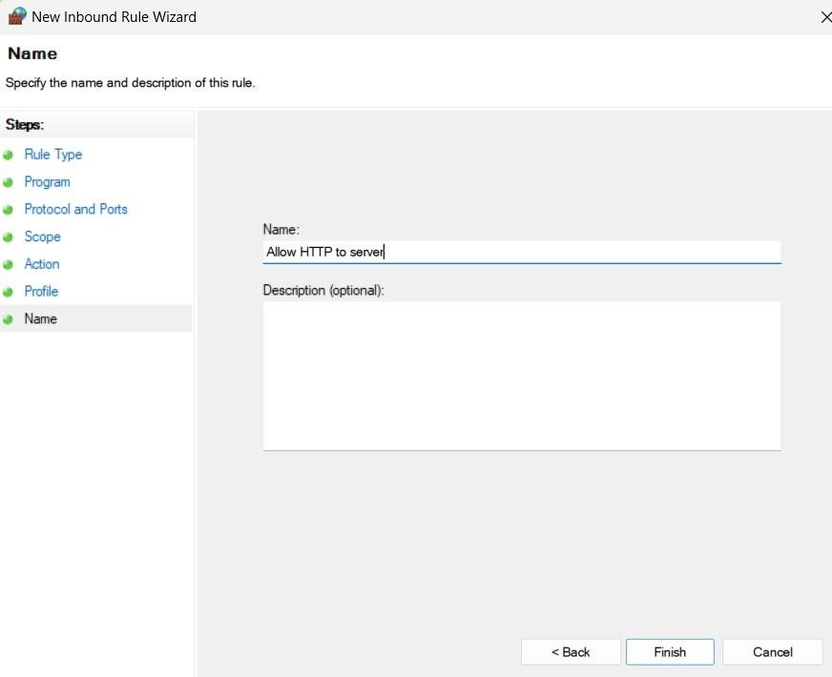

And select finish.

Now open XAMPP server –

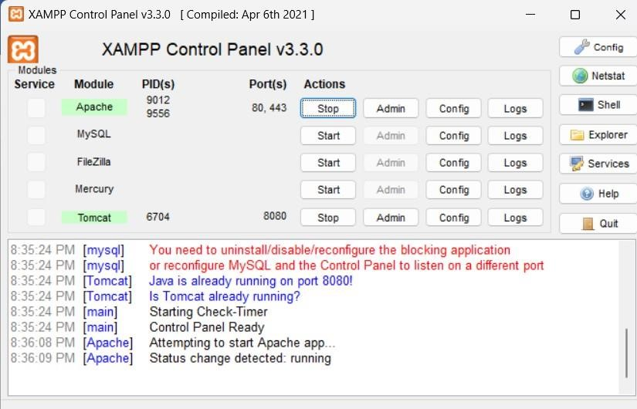

# Local device has same internet connection as laptop –

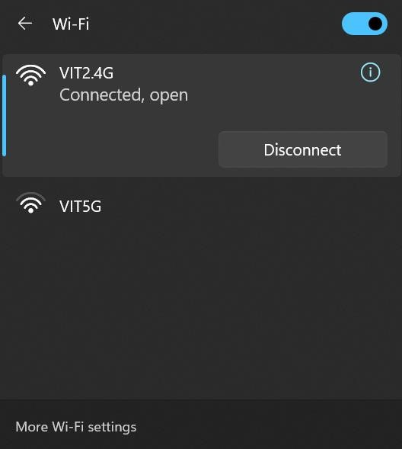

# Note the IPv4 address for the network –

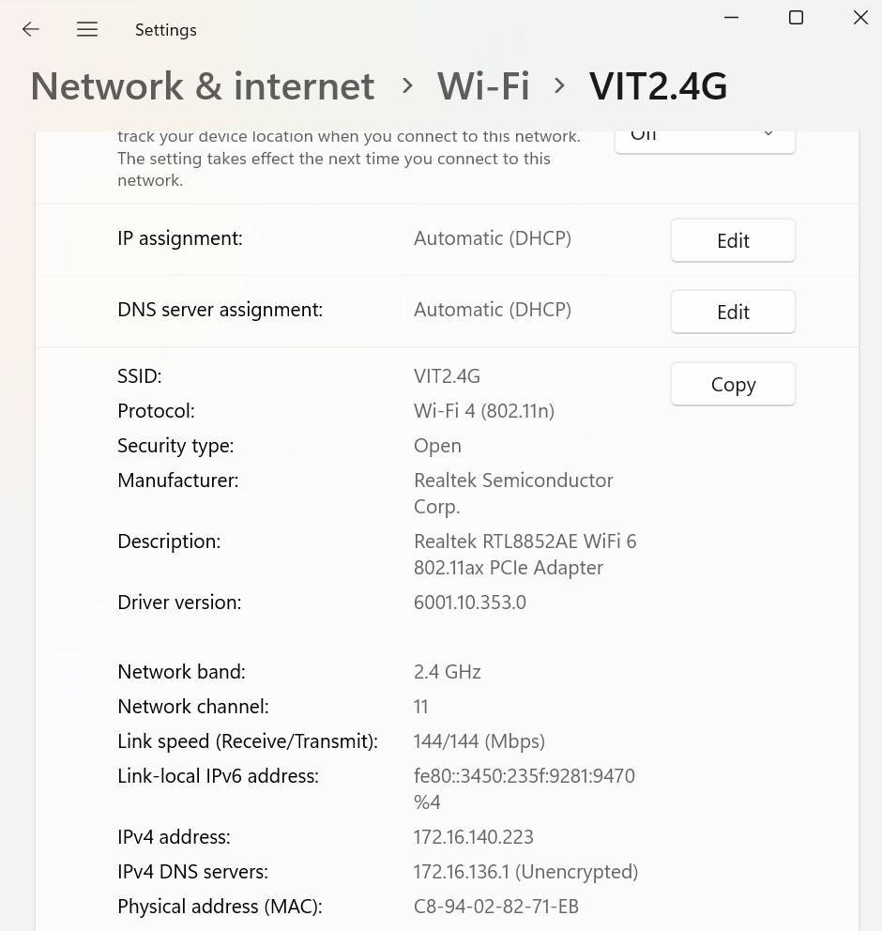

# Now input the same ipv4 address to local device –

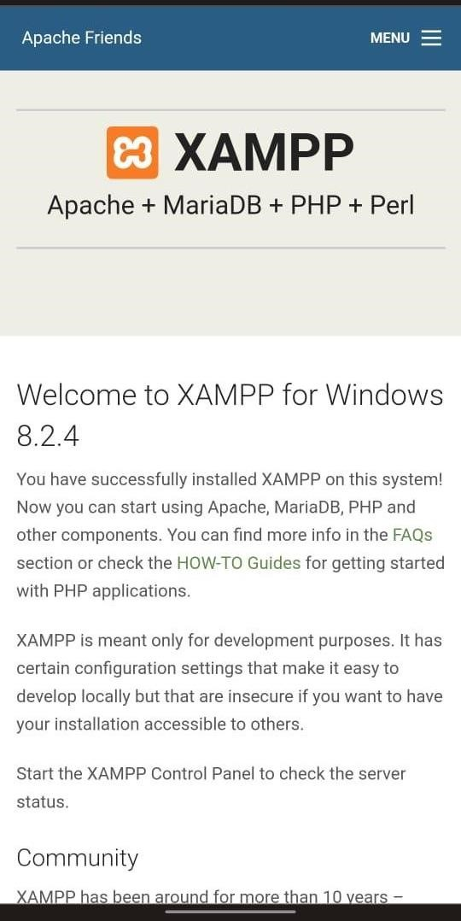

CSI3022-Cyber Security and Application Security

Lab Assessment-6

**1.Design a system to detect all the instances of an attack using signatures SQL Injection:**

SQL injection is a type of security vulnerability that occurs when an attacker is able to manipulate a database query through user input. It happens when user input is not properly sanitized or validated before being used in a SQL query. The attacker can then insert malicious SQL code, potentially leading to unauthorized access, data manipulation, or even deletion.

**Signature for SQL Injection:**

Code:

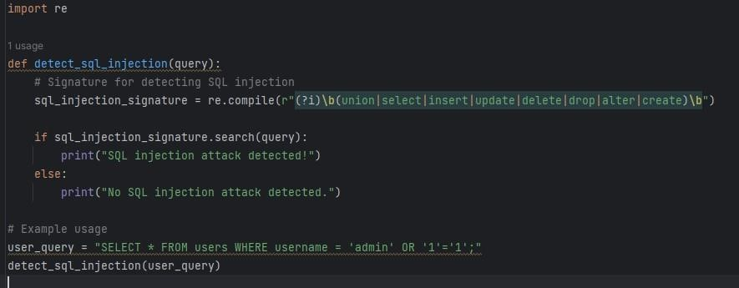

OUTPUT:

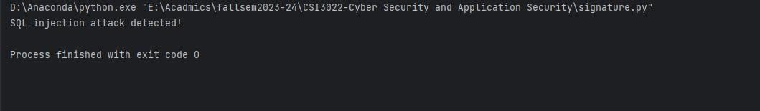

Code: import re #1 usage def detect sql injection (query):

# Signature for detecting SQL injection

sql_injection_signature = re.compile(r" (?i)\b(union|select|insert|update|delete |drop|alter|create)\b")

if sql_injection_signature.search(query):

print("SQL injection attack detected!")

else: print("No SQL injection attack detected.")

#Example usage user_query="Sanjana" detect_sql_injection (user_query)

Output:

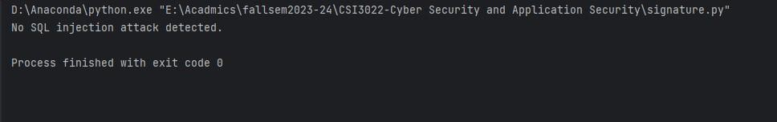

Brute Force Attack:

Brute force is a straightforward approach where the system attempts every possible combination until it finds a solution. It's not always the most efficient method, but it can be effective. For example, a brute force attack on a password involves trying every possible password until the correct one is found.

**Signature for brute force attack:**

Attack Detected code:

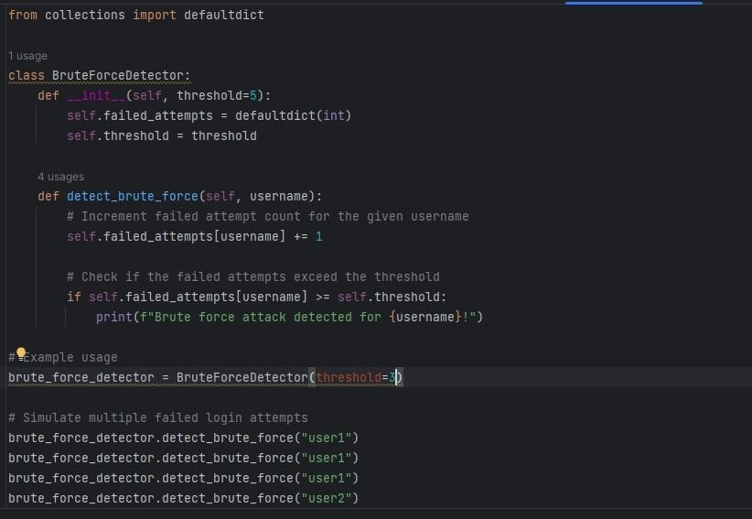

Code:

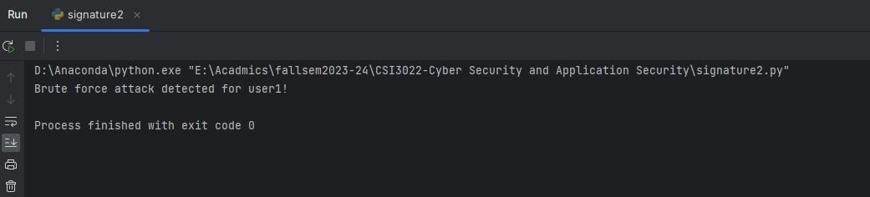

Attack Not Detected code:

Code:

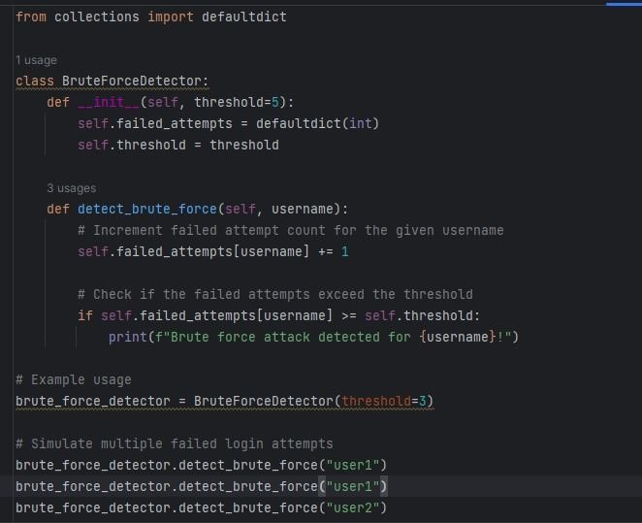

Output:

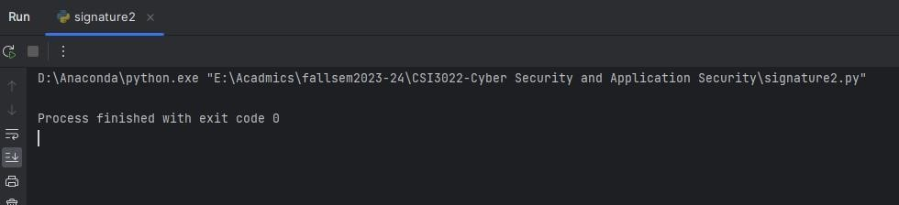

**XSS attack:**

Cross-Site Scripting (XSS) is a type of security vulnerability that occurs in web applications when an attacker injects malicious scripts into web pages that are viewed by other users. The goal of an XSS attack is typically to steal sensitive information, such as login credentials or session tokens, or to perform actions on behalf of the user without their consent.

**Signature for XSS attack:**

Attack detected code:

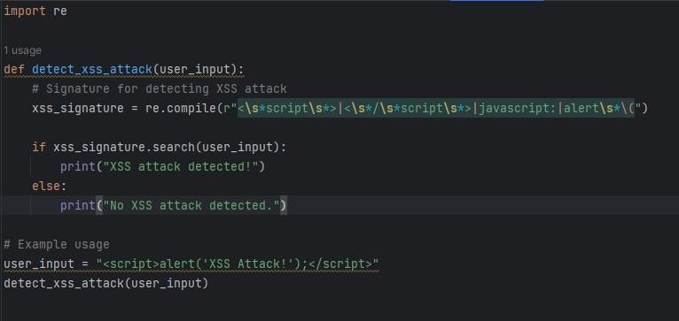

Output:

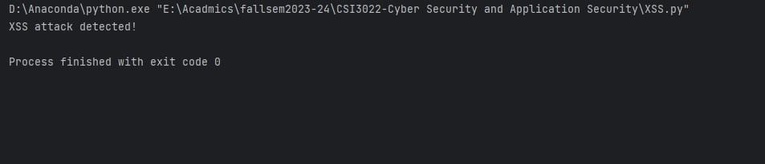

Attack Not detected code:

import re #1 usage def detect_xss_attack (user_input): #Signature for detecting XSS attack

xss_signature=re.compile(r"<\s*script\s*>|<\s*/\s*script\s*>|javascript:|alert\*

\(") if xss_signature.search(user_input):

print("XSS attack detected!")

else:

print("No XSS attack detected.")

#Example usage user_input = "Sanjana" detect_xss_attack(user_input) Output:

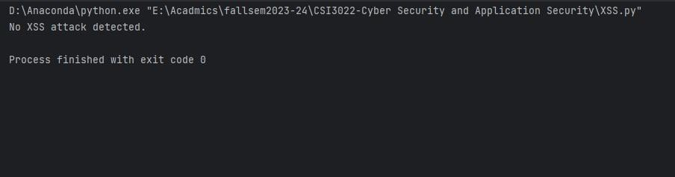

**Spoofing:**

Spoofing refers to the act of disguising or falsifying information to deceive others, often with malicious intent. It can occur in various contexts, and different types of spoofing exist.

**Signature for Spoofing attack:**

Attack Detected Code:

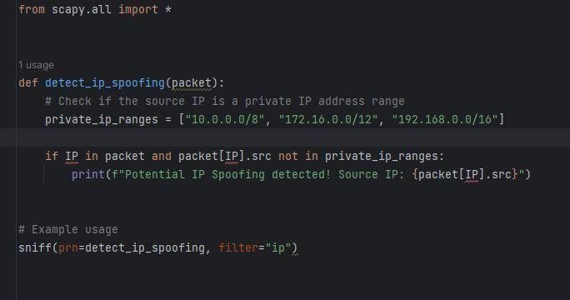

Output:

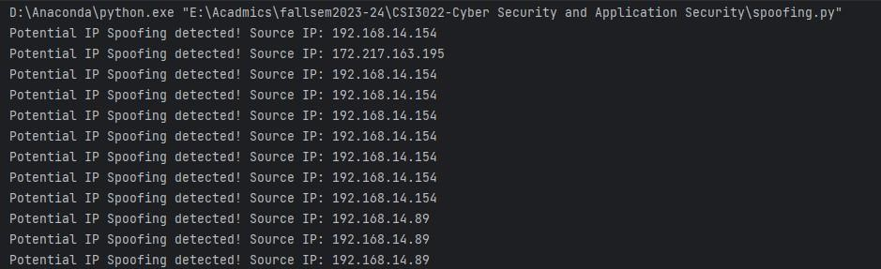

**2.Examine network traffic and identify potentially malicious traffic**

Step1:Open the wireshark and select the wifi option to receive the packet

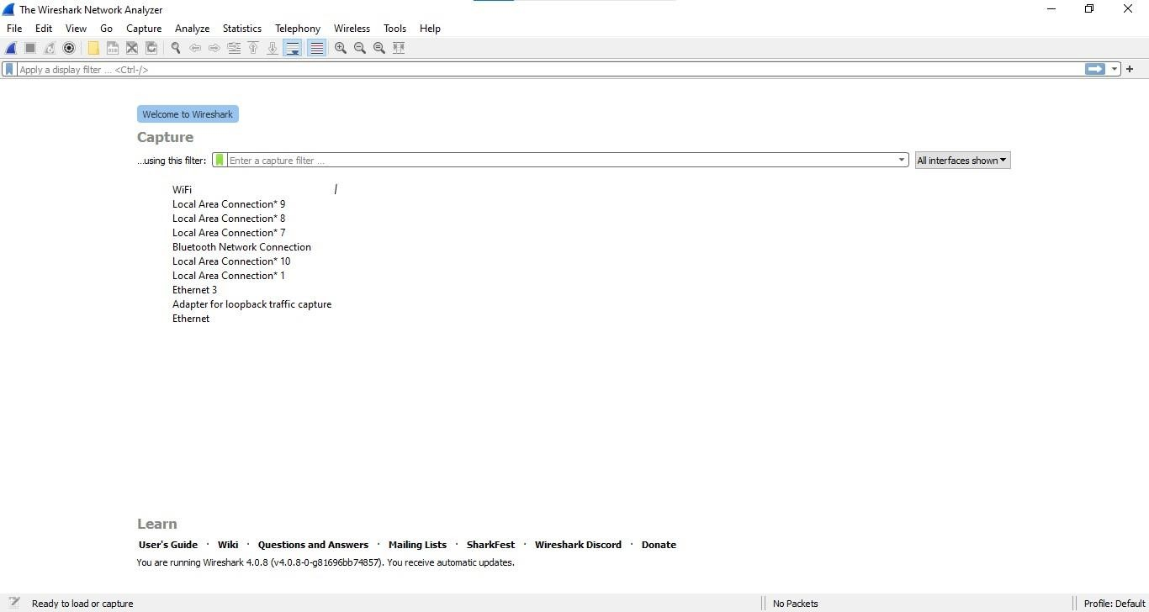

Step 2: Creating an ICMP packet with error type 5 and send the packets through wifi

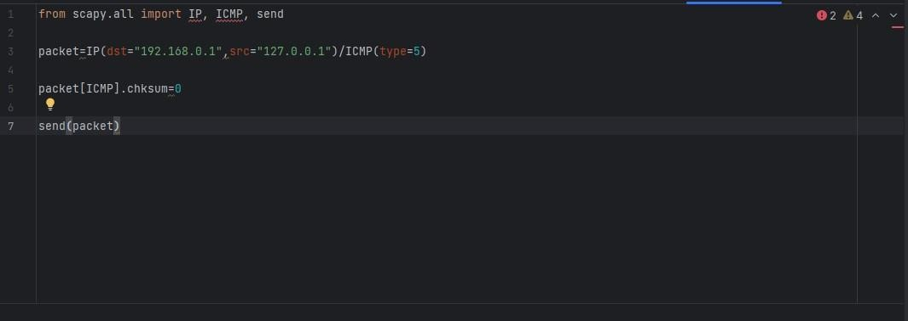

Step 3:Detecting the packets using Wireshark software

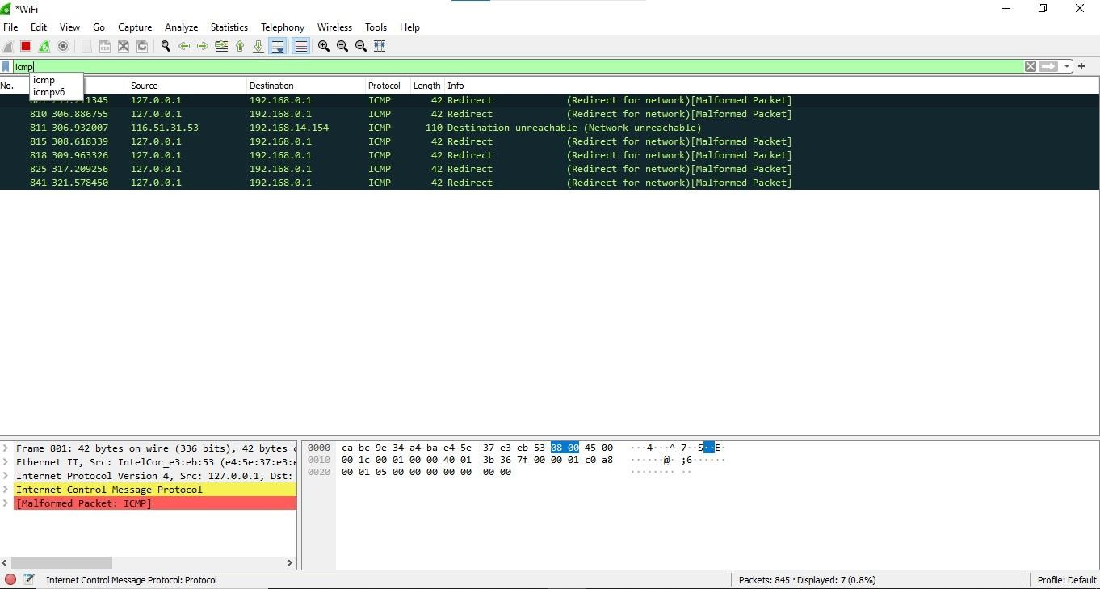

Step 4: Creating an ICMP packet with error type 4 and send the packets through wifi.

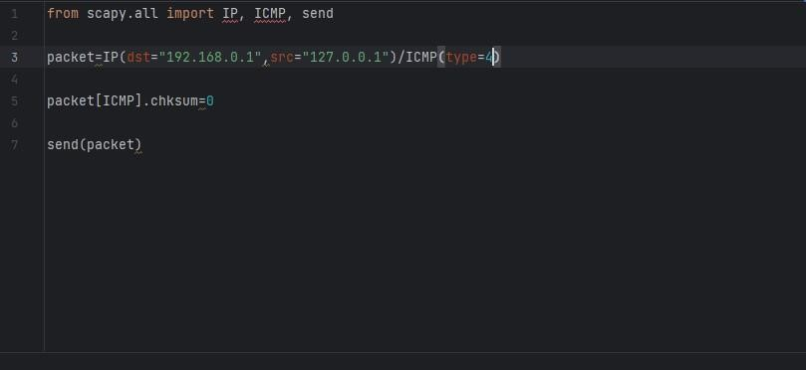

Step 5: Detecting the packets using Wireshark software.

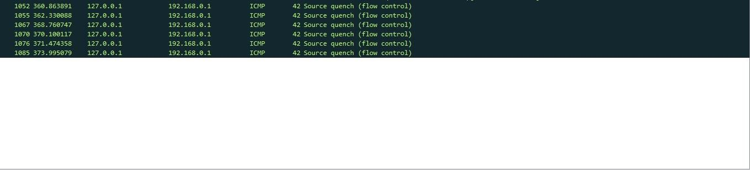

Step 6: Creating an ICMP packet with error type 6 and send the packets through wifi.

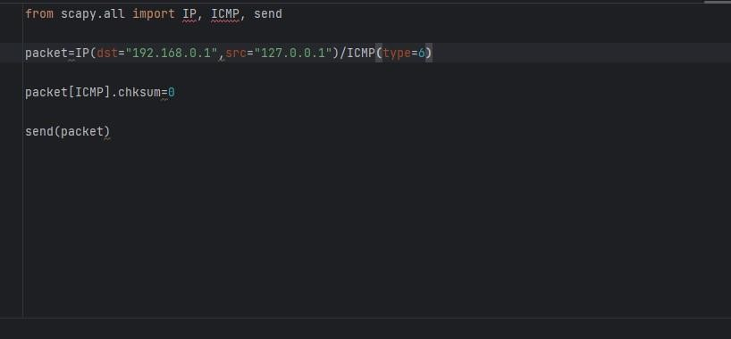

Step 7: Detecting the packets using Wireshark software.

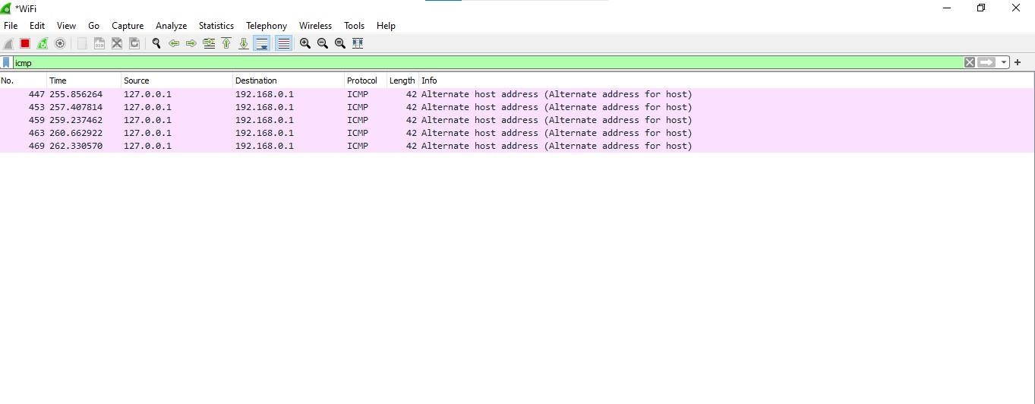

Step 8: Detecting the TCP retransmission using wireshark

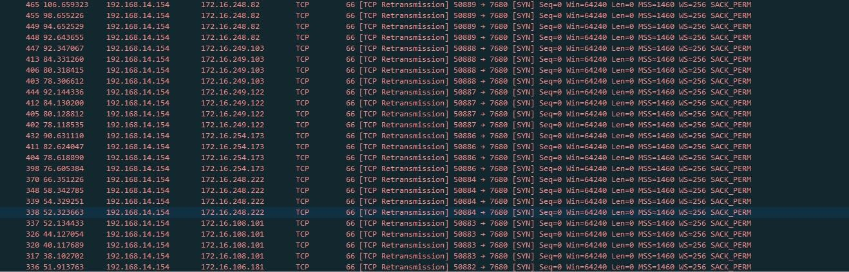

Step 9: Detecting the TCP vulnerability packet using wireshark

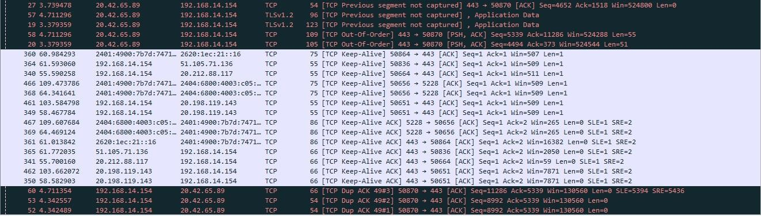

Step 10: Printing the I/O graphs for the wifi which tells the no.of packets vs the time

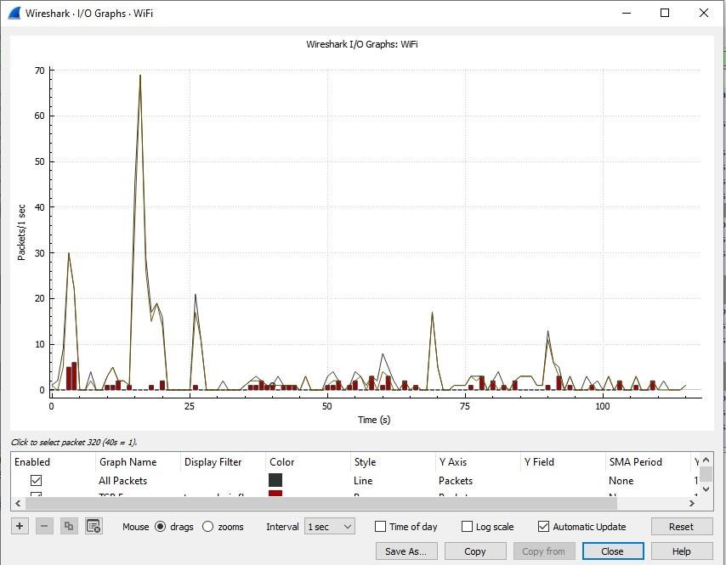

Step 11: Printing the packet length and how many packets has been received within the length of the packet

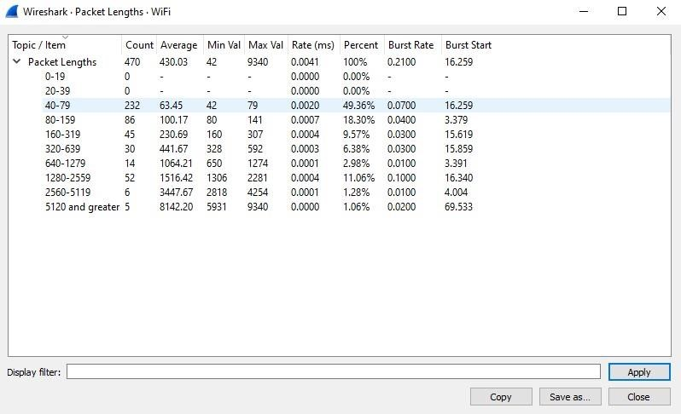

Step12: Printing the protocol Hierarchy Statistics

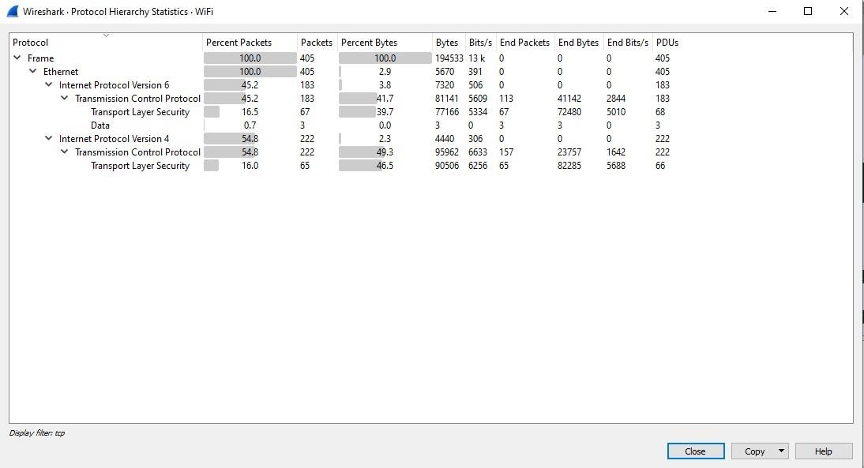

Step 13: Printing the transmission flow of every type of TCP Packet so we can get the insight of every different type of TCP Packets

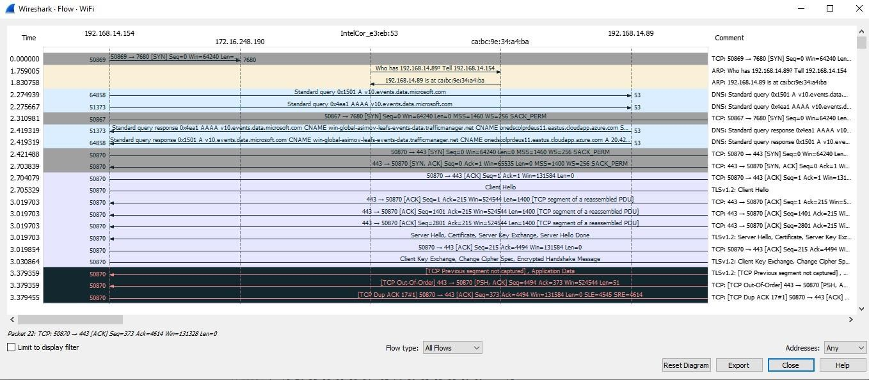

Step 14: Printing all IPv4 addresses the local machine established connection with other devices.

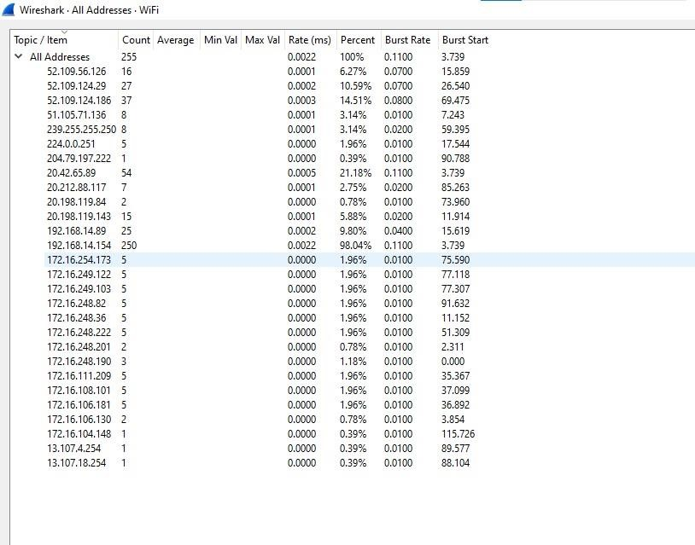

Step 15: Printing all IPv6 addresses the local machine established connection with other devices.

